Law Office Automation Tools 2003
Systems Administration Guide

Table of Contents
Introduction 3
KI Database Administrator 4
Firm Names Administration 5
User Names Administration 7
Client Matter Administrator 12
Data Dictionary 16
Data Dictionary: Letter Closing Preferences 17
Mailing Certifications Administration 19
Data Dictionary: Mailing Codes Administration 21
Matter Categories Administration 23
Data Dictionary: Phone Categories Administration 25
Data Dictionary: States Administration 27
Forms Administration 29
Required Client Workstation Application Files 33
Word’s Template, Workgroup, and Startup Paths 33
User Templates 34
Workgroup Templates 34
Pleading Templates 35
Litigation Support 35
Forms Files 36
Startup-Path Files 36
Windows Files 36
Windows System Files 37
KI Help 37
KI Admin Logos 37
Configuring the Workstation 38
Forms Bank Organizer 40
Create a Standard Text Form 40
Create a Form with Fill-In Fields 41
Create a Form with Form Fields – Standard or Protected 43
Create a Macro Form 47
Logo Builder 48
Logo Builder 48
Modifying Stylized Logos 48

MAPI Connector 51
Add KI Systems Address Book To your mail profile 51
Outlook Address Book(s) 54
Remote Version 55
Go Mobile 56
Go Network 57
Outlook Synchronizer 58
Recommendations Before you run the Outlook Synchronizer 59
Using KI Outlook Synchronizer 60

Introduction
This manual provides a step-by-step process for configuring workstations, managing the employee database, modifying firm logos, adding Forms to the Forms Organizer, installing and configuring Remote Version, MAPI connector and Outlook Synchronizer.

Your firm may not have purchased all of these products but they are included in this manual in the event that your firm purchases them at a later date.

KI Database Administrator
Overview
KI Database Administrator (KIADMIN.exe), provides the System Administrator with tools to manage settings and options used in customization. Many of the settings & options managed via KIAdmin apply globally within the firm accessing the database, while other settings & options apply specifically to the individual user(s), based on their preferences.

Features:
Firm Names Administration tab. Information stored here is inserted into all signature blocks and in the title bar on dialog boxes. Location of the Caption Bank and the type of firm file save that will be used is also stored under Firm Names.

User Names Administration tab. Data stored here is accessed at various points during the document creation process. Information such as signature names, document numbering, DID number, and email address in letters and merge letters is stored here.

Client Matter Administration tab. Client Matter Numbers and descriptions are added or deleted here. Once entered into the system, client matter numbers are available to users to attach to database records for reference, searching, and mail merge functions.

Data Dictionary tab. Lists for closing preferences, mailing codes, logos, phone categories and states are managed here.

Forms Administration tab. Forms are added to or deleted from the Forms index using this tool.

Firm Names Administration

Overview:
Firm Names Administration is a feature that stores Branch Office information for firms with single or multiple locations. Firm Names are managed through the Database Administrator.

To navigate around the Database Administrator, use the mouse, the tab and Enter keys or the assigned accelerator keys.

To Add or Edit Firm Names Entries
- To access Database Administrator from Start, Run Menu.
- Enter "kiadmin" in the text box and click OK.
- The Firm Names tab is visible and the following screen appears:

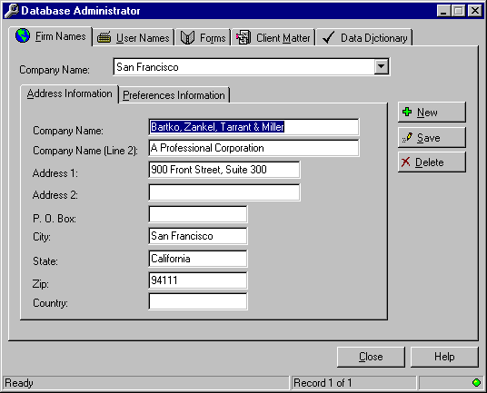

- An entry must be made for every office in your firm.
- Complete the information on the Address Information tab.

Note: It is not necessary to type in the words "P.O. Box" in the PO box field.
- Continue on to the Preferences Information tab.

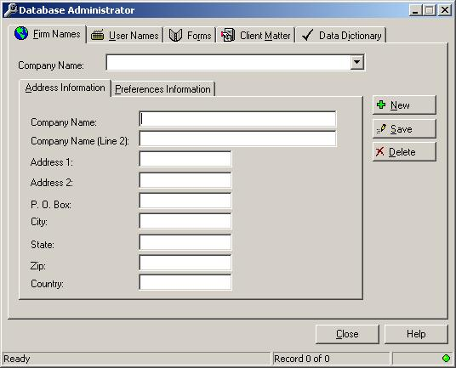

- Enter the Main Phone number of the current office.
- Enter the Fax Phone number.
- If you are using the Pleading Pak templates, enter the path where Caption Bank entries will be stored.

There are two Caption Bank Options:
User Selected Location option allows you to direct caption bank entries to any location you want.
Use Central Caption Bank option forces all caption bank entries to a location on the network for all users to share.
- Select the one best for your work environment.

There are three User Save Options:
Do not use Document Numbering will allow you to save documents use Word's default saving feature.
Use (Document Management System Name) is chosen if your firm has such a system.
Use Document Numbering allows you to save using KI System's File Save feature.
- Select the one best for your work environment.
- In the Location field, enter the name of the office or branch associated with the information provided on the Address Information and Preferences Information tabs.
- Press Alt+S or click on the Save button to save the record.

User Names Administration

Overview:
User Names is a database feature that stores the following information for employees of the firm:

- Preference Name
- Preference Initials
- User Initials
- File Save Initials
- File Save Number
- Network Initials
- Direct Dial Phone Number
- Direct Dial Fax Number
- Letter Salutation Preference
- Default Address Book
- Letterhead Options
- Letter Closing Preference
- Office Location
- E-Mail Address
- Bar Number

These preferences are managed using the Database Administrator. Modifications and additions made to this database should be performed by the System Administrator only because the data stored here affects a user's login capability and desktop preferences.

To navigate around the Database Administrator, use the mouse, the tab and Enter keys or the assigned accelerator keys.

- Outlined below are instructions for editing, adding and deleting records.

To Edit User Names
- Access the Database Administrator from the Start, Run Menu.
- Enter "kiadmin" in the text box and click OK.
- Click on the User Names tab or press Alt+U.
- Click on the Address Book button to access the Employee Information stored in the database.
- Query the Address Book for the record you need to edit.
- Highlight the name in the Query Results screen.

Click OK and the User Names tab appears filled in with the employee's default information.

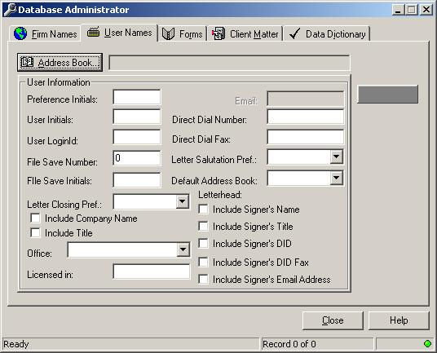

- Position the cursor in the field to be edited and make your changes.
- Click on Save when you are done.
- Click Close to exit the Database Administrator program.

To Add a User Name
- Access the Database Administrator from the Start, Run Menu.
- Enter "kiadmin" in the text box and click OK.
- Click on the User Names tab or press Alt+U.
- Click on the Address Book button.
- Click on the Address tab.

- The following screen appears:

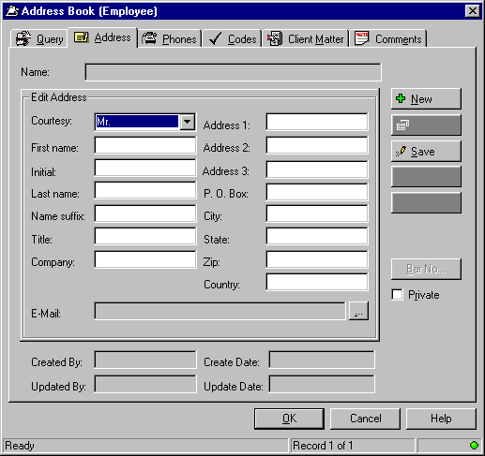
- The screen should be void of information, except for the default Courtesy Title of "Mr." If this is not the case:

- Press Alt+N or click on the New button to clear your screen.

- Fill in the following fields: Courtesy, First name, Initial, Last Name and E-Mail.
- Press Alt+S or click on the Save button to save the record.

- If the employee has a bar number:

- Click on the Bar Number button.
- The following screen appears:

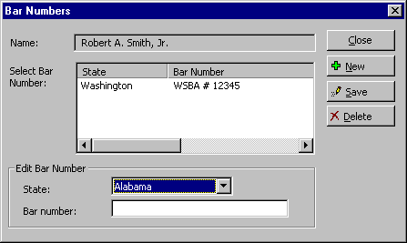

- Select a state from the State drop down list.
- Tab to the Bar number text box and enter the bar number.
- Click on Save.
- If more than one bar number needs to be entered, click on the New button and begin the process again.
- Click Close when you are done.
- Click OK to return to the User Names tab.

Entering Data in the User Names tab:
- Preference Name. This will be filled in from the prior screen.
- Preference Initials. Enter the user’s preferred initials for closings. Note: These do not necessarily need to correspond to the Preference Name.
- User Initials. Enter the user’s initials. This field allows insertion of an individual’s preferred signature name from the database.
- File Save Initials. File Save Initials can be letters, numbers or a combination of letters and numbers. Each individual’s File Save Initials must be unique. If your firm uses a Document Management System, this field can be left as is.
- File Save Number. The default is 0, so the first document saved will increment from 001. A combination of numbers and letters are used, allowing up to 46,555 unique document names per individual. If your firm uses a Document Management System, this field should match the user loginID.
- Network Initials. Enter the user’s network login name or loginID
- Letter Closing Preference. Select a default closing preference for this user's letters.
- Include Company Name. Check this box if the user would like, by default, the firm's name to appear in the signature blocks of letters.
- Include Title. Check this box if the user would like, by default, her/his title to appear in the signature blocks of letters.
- Office. Select the appropriate office from the drop down list.
- Direct Dial Number. Enter the user’s Direct Dial Number.
- Letter Salutation Preference. Select from the drop-down list to set the user’s default This preference can be changed while creating letters.

- Default Address Book. Select from the drop-down list to set the user’s default Address Book. The user will still have access to other address books, as applicable.
- Letterhead Options. Check off the items the user would like to be inserted in the letterhead of letters. These options can be changed while creating letters. When you are done entering data, click on Save.

To Delete User Names
- Access the Database Administrator from the Start, Run Menu.
- Enter "kiadmin" in the text box and click OK.
- Click on the User Names tab or press Alt+U.
- Click on the Address Book button.
- Query the database for the record you want to delete.
- Highlight the name in the Query Results area.
- Click on the Address tab.
- The following screen appears:

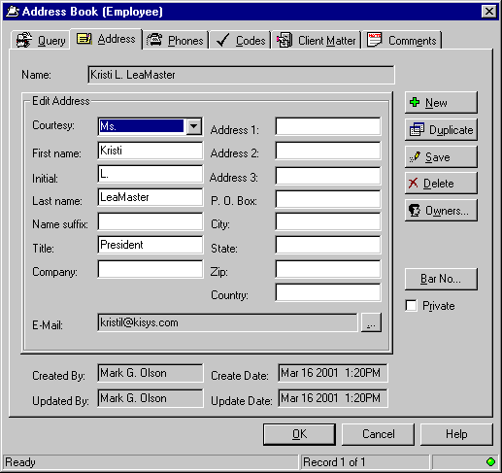

- Click on the Delete button.
- A confirmation window will appear. Click Yes or No as appropriate.

- Click OK then Close to exit the Database Administrator.

Client Matter Administrator

Overview:
Client Matter is a database feature that stores information on Clients that is used primarily in Address Book queries. Client Matter Names and Numbers are managed through the Database Administrator. Client Matter information can be added, edited or deleted using this feature.

To navigate around the Database Administrator, use the mouse, the tab and Enter keys or the assigned accelerator keys.

To Add Client Matter Entries
- Access the Database Administrator from the Start, Run Menu.
- Enter "kiadmin" in the text box and click OK.
- Press Alt+M or click on the Client Matter tab.

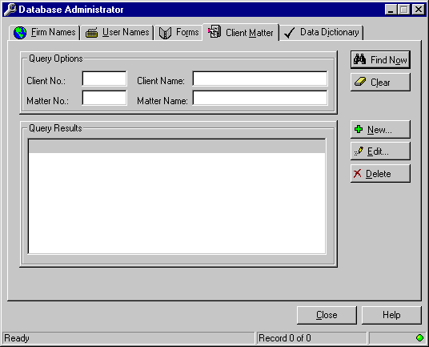

- Enter full or partial information in any of the Query Options fields. You can also use the wildcard character %.
- Click Find Now.
- If the matter does not exist, create it by clicking on the New button or pressing Alt+N.

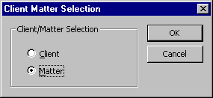
- If the Client exists in the database, select Matter and click OK to continue.
- If this is a new Client, select Client and supply the information on the New Record screen.
- Press OK to continue

- Note: A Client Number must exist before you will be able to add a Matter Number. If you attempt to create a duplicate Client Number, you will receive a database error.

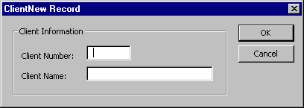
- If the Client Number already exists, select the New button from the Client Matter tab.
- From the Client Matter Selection options, select Matter and press OK.

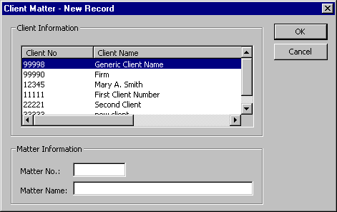
- From the Client Information drop down list, select the appropriate Client Number.
- Complete the information in the Matter No. and Matter Name boxes. Click on OK to continue.

To Edit Client Matter Information
- Access the Database Administrator from the Start, Run Menu.
- Enter "kiadmin" in the text box and click OK.
- Click on the Client Matter tab.
- Enter full or partial information in any of the Query Options fields. You can also use the wildcard character %.
- Click Find Now.
- The following screen appears:

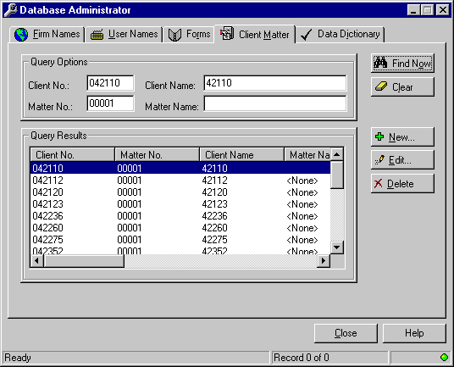
- From the Query Results area, highlight the client matter to be modified.
- Click on the Edit button or press Alt+E to continue.

To Delete Client Matter Entries
- Access the Database Administrator from the Start, Run Menu.
- Enter "kiadmin" in the text box and click OK.
- Click on the Client Matter tab.
- Enter full or partial information in any of the Query Options fields. You can also use the wildcard character %.
- Click Find Now.

- The following screen appears:

- From the Query Results area, highlight the client matter to be deleted.
- Click on the Delete button or press Alt+D. You will be prompted to confirm deletion of the record.
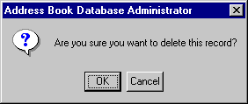

- Press OK or Cancel as appropriate.

Data Dictionary

Overview:
Data Dictionary is a feature of Address Book, listing preferences for Letter Closings, Mailing Certifications, Mailing Codes, Matter Categories, Phone Categories, and States (for bar numbers).

Please note: There is a category called Logo Label Type that you will not alter. This is used by some of the code embedded in the customized software. To modify the logos for your firm, refer to the Logo Builder chapter in this manual.

To Access Data Dictionary:
- Access the KI Admin Tools from the Start, Run Menu.
- Enter "kiadmin" in the text box and click OK.
- Click on the Data Dictionary tab or press Alt+I.

- The following screen appears:

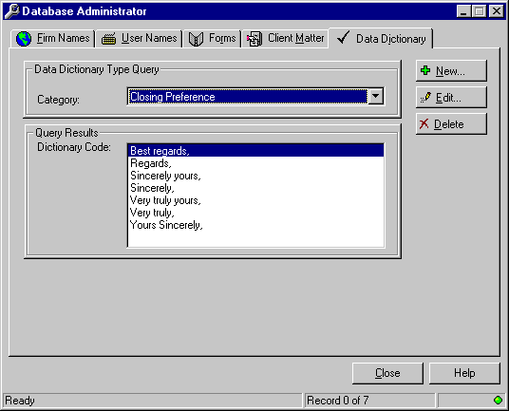

- Select the category you want from the drop down list.

Data Dictionary: Letter Closing Preferences

Overview:
The Database Administrator allows you to edit, add and delete letter closings available to users in your firm using the Data Dictionary Administration feature.

Once the list has been modified to fit your needs, every individual in the firm can be assigned a default letter closing preference. Each user will still have the ability to select a different closing from the drop down list as part of the letter creation process.

To navigate around the Database Administrator, use the mouse, the tab and Enter keys or the assigned accelerator keys.

To Modify Letter Closing Preferences
- Access the KI Admin Tools from the Start, Run Menu.
- Enter "kiadmin" in the text box and click OK.
- Click on the Data Dictionary tab or press Alt+I.
- In the drop down list of categories, select Closing Preferences.

- The following screen appears:

- To add a new closing, click the New button.

- The following screen appears:

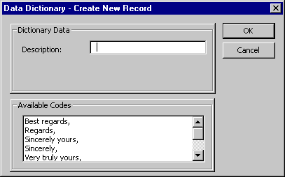

- Enter the new letter closing in the Description area, exactly as it should appear in a letter, including the comma.
- Press OK.
- To edit an existing closing, highlight the closing in the Query Results area and press Edit.
- Make the changes in the Description field.
- Press OK.
- To delete an existing closing, highlight the closing in the Query Results area and press Delete.

- The following confirmation screen will appear:

- Press OK or Cancel as appropriate.

When you are done with the Database Administrator, click on Close

Mailing Certifications Administration

Overview:
The Database Administrator allows you to edit, add and delete mailing certifications that are used for letters, envelopes and labels.

To navigate around the Database Administrator, use the mouse, the tab and Enter keys or the assigned accelerator keys.

To Modify Mailing Certifications
- Access the KI Admin Tools from the Start, Run Menu.
- Enter "kiadmin" in the text box and click OK.
- Click on the Data Dictionary tab or press Alt+I.
- In the drop down list of categories, select Mailing Certifications. There are already several certifications in this list.

- The following screen appears:

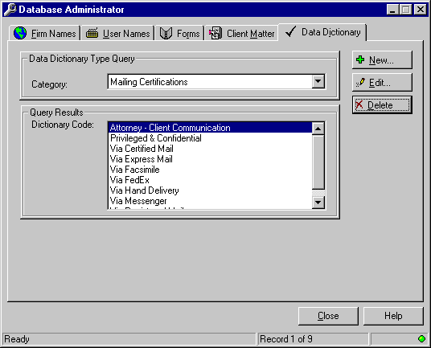
- To add a new mailing certification, click the New button.
- The following screen appears:
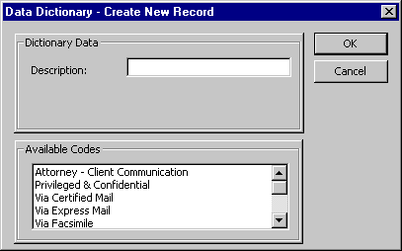

- Enter the new certification in the Description field.
- Press OK.
- To edit an existing certification, highlight it in the Available Codes area and press Edit.
- Make the changes in the Description field.
- Press OK.
- To delete an existing certification, highlight it in the Available Codes area and press Delete.

- The following confirmation screen will appear:

- Press OK or Cancel as appropriate.
- When you are done with the Database Administrator, click on Close.

Data Dictionary: Mailing Codes Administration

Overview:
The Database Administrator allows you to edit, add and delete mailing codes that are used for merge printing.

To navigate around the Database Administrator, use the mouse, the tab and Enter keys or the assigned accelerator keys.

To Modify Mailing Codes
- Access the KI Admin Tools from the Start, Run Menu.
- Enter "kiadmin" in the text box and click OK.
- Click on the Data Dictionary tab or press Alt+I.
- In the drop down list of categories, select Mailing Codes.

- The following screen appears:

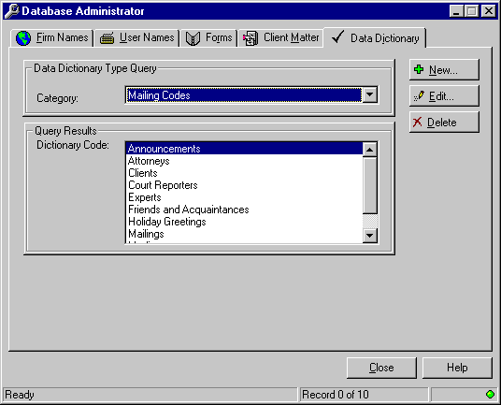
- To add a new mailing code, click the New button.
- The following screen appears:

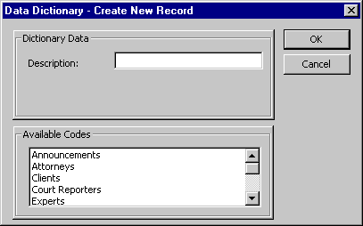

- Enter the new code in the Description area.
- Press OK.
- To edit an existing code, highlight the code in the Query Results area and press Edit.
- Make the changes in the Description field.
- Press OK.
- To delete an existing code, highlight the code in the Query Results area and press Delete.

- The following confirmation screen will appear:

- Press OK or Cancel as appropriate.
- When you are done with the Database Administrator, click on Close.

Matter Categories Administration

Overview:
The Database Administrator allows you to edit, add and delete matter categories that are used when assigning Client Matter information to records in the Address Book.

To navigate around the Database Administrator, use the mouse, the tab and Enter keys or the assigned accelerator keys.

To Modify Matter Categories
- Access the KI Admin Tools from the Start, Run Menu.
- Enter "kiadmin" in the text box and click OK.
- Click on the Data Dictionary tab or press Alt+I.
- In the drop down list of categories, select Matter Categories. There are already several categories in this list.
- The following screen appears:

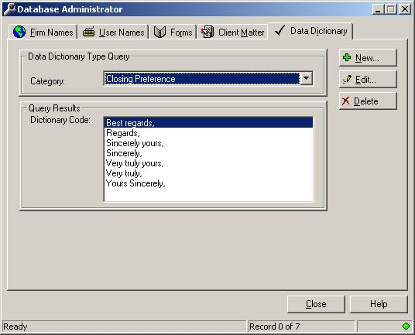
- To add a new mailing certification, click the New button.
- The following screen appears:

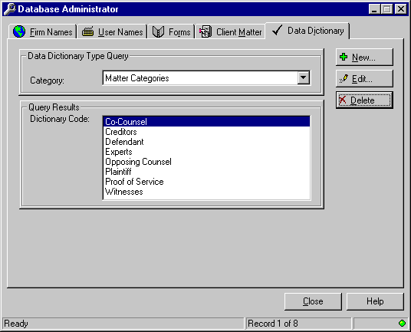

- Enter the new category in the Description field.
- Press OK.
- To edit an existing category, highlight it in the Available Codes area and press Edit.
- Make the changes in the Description field.
- Press OK.
- To delete an existing category, highlight it in the Available Codes area and press Delete.

- The following confirmation screen will appear:

- Press OK or Cancel as appropriate.
- When you are done with the Database Administrator, click on Close.

Data Dictionary: Phone Categories Administration

Overview:
The Database Administrator allows you to edit, add and delete phone categories that are available in the firm's Address Book. NOTE: please do not delete any existing phone categories.

To navigate around the Database Administrator, use the mouse, the tab and Enter keys or the assigned accelerator keys.

To Modify Phone Categories
- Access the KI Admin Tools from the Start, Run Menu.
- Enter "kiadmin" in the text box and click OK.
- Click on the Data Dictionary tab or press Alt+I.
- In the drop down list of categories, select Phone Categories.

- The following screen appears:

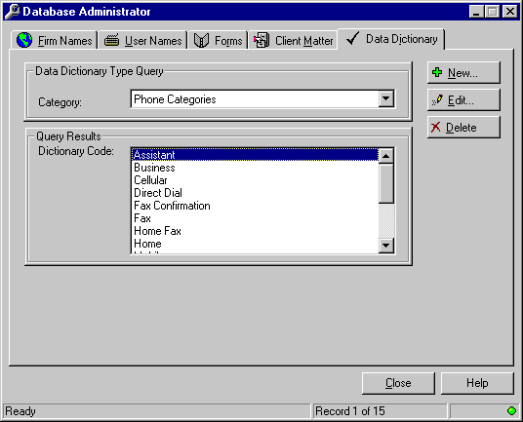

- To add a new phone category, click the New button.
- The following screen appears:

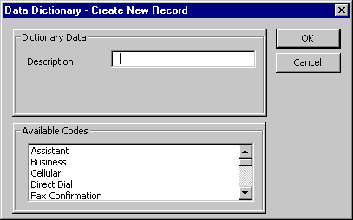

- Enter the new category in the Description area.
- Press OK.
- To edit an category, highlight the category in the Query Results area and press Edit.
- Make the changes in the Description field.
- Press OK.
- To delete an existing category, highlight the category in the Query Results area and press Delete.
- The following confirmation screen will appear:

- Press OK or Cancel as appropriate.
- When you are done with the Database Administrator, click on Close.

Data Dictionary: States Administration

Overview:
The Database Administrator allows you to edit, add and delete the names of states for bar number information. By default, the Address Book, as installed, has all fifty states listed in the States Category. This tool allows you to edit the list to include only those states in which attorneys are licensed.

US Tax Court and Patent number types may also be created in this category.

To navigate around the Database Administrator, use the mouse, the tab and Enter keys or the assigned accelerator keys.

To Modify the List of States
- Access the KI Admin Tools from the Start, Run Menu.
- Enter "kiadmin" in the text box and click OK.
- Click on the Data Dictionary tab or press Alt+I.
- In the drop down list of categories, select States.
- The following screen appears:

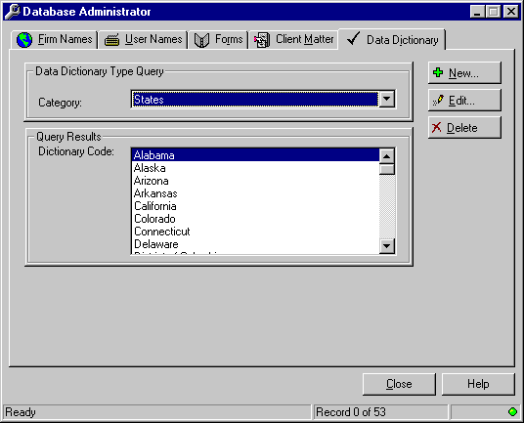

- To add a new state, click the New button.
- The following screen appears:

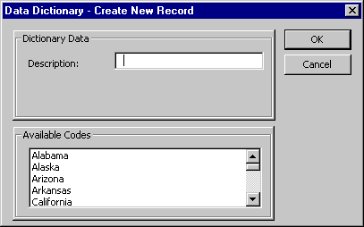

- Enter the new state in the Description area.
- Press OK.
- To edit an existing state name, highlight the state in the Query Results area and press Edit.
- Make the changes in the Description field.
- Press OK.
- To delete an existing state name, highlight the state in the Query Results area and press Delete.
- The following confirmation screen will appear:

- Press OK or Cancel as appropriate.
- When you are done with the Database Administrator, click on Close.

Forms Administration

Overview:
Forms Administration is a database feature that provides a means to add standardized forms to a central form bank for shared access by multiple users. Forms are managed through the Database Administrator.

To navigate around the Database Administrator, use the mouse, the tab and Enter keys or the assigned accelerator keys.

Outlined below are instructions for adding and editing Forms entries to the Form Bank. To create Forms please refer to the Form Bank Organizer portion of this manual.

To Add Forms Entries
- Access the Database Administrator from the Start, Run Menu.
- Enter "kiadmin" in the text box and click OK.
- Click on the Forms tab.

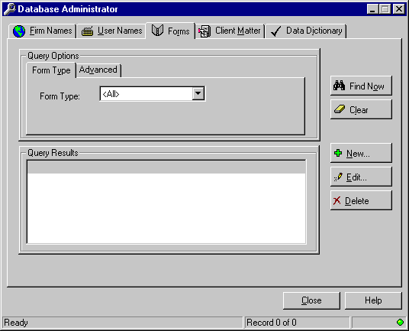

- Click on the New button.
- Complete the information on the Forms - Create New Record screen.

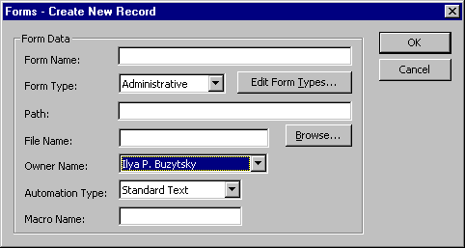

- Provide a name in the Form Name field. This is the name the user will see in the Query results screen when searching for a form.
- If the Form Type you want does not appear in the drop-down list, click on the Edit Form Types button.
- Click on the New button and provide a Description
- Click on Save then OK.
- Click on the Browse button to locate the form.
- Navigate to the location where the form resides and double click on the file name.
- The document name will appear in the File Name text box and the Path will be completed automatically.
- Select the Form Owner Name from the drop-down list.
- Select the appropriate option from the drop-down list: Standard Text, Word Fill-in Fields, Word Form Fields Standard and Macro.
Standard Text option represents insertion of straight text only, with no variables.
Word Fill-in Fields option prompts users to enter text in “pop up” text fields.
Word Form Fields standard option allows users to move from field to field entering text in the form (without prompts) until all fields are completed. Note: Tabbing out of the last field will unlock the Form.
Word Form Fields – Protected Option allows users to move from field to field entering text in the form (without prompts). Tabbing out of the last filed will not unlock the form for additional editing.
Macro Automation option allows users to access forms created using VBA programming language, with option buttons, drop-down lists, and fill-in text boxes. If this option is selected, the name of the Macro must be included in the Macro Name box. Note: Macros must be stored in the KI Forms.dot template located in the Startup directory in order to function properly.
- If the form Automation Type is Macro, then provide the Macro Name.
- Press OK when done.

To Edit Forms Entries
Note: These are the instructions for editing the entries in the Form Bank, not for editing the actual forms. To edit forms, open the form in Word and begin editing.

- Access the Database Administrator from the Start, Run Menu.
- Enter "kiadmin" in the text box and click OK.
- Click on the Forms tab.

- Select a form type from the Form Type drop-down list, or use the default <All> to view all available forms.
- Click on the Find Now button.
- Click on the one you want.
- Click on the Edit button.
- Edit the fields as appropriate.
- Press OK then Close to exit the Database Administrator.
You may create forms in Word form existing documents or new documents you create. For detailed tips on Form Automation please refer to the Form Bank Organizer portion of this manual.

To Delete Forms Entries
- Access the Database Administrator from the Start, Run Menu.
- Enter "kiadmin" in the text box and click OK.
- Click on the Forms tab.

- Select a form type from the Form Type drop-down list, or use the default <All> to view all available forms.
- Click on the Find Now button.
- Click on the one you want.
- Click on the Delete button.
- The following confirmation screen will appear:

- Press OK or Cancel as appropriate.
- When you are done with the Database Administrator, click on Close.

Required Client Workstation Application Files

The following is a listing of the required Client Workstation System files for the Customization and Client Address Book system.

Word’s Template, Workgroup, and Startup Paths

To illustrate local Word’s pathing, here is a screen shot from within Word 2003:

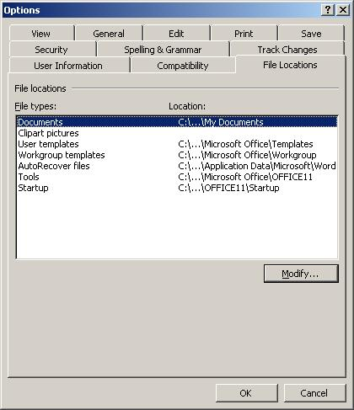

To access this screen, click Tools, Options, File Locations. Please note that the User templates, Workgroup templates and Startup paths have been truncated. The three dots represent the folder Program files. For example, the complete path for startup would be: c:\program files\microsoft office\office\startup. You must follow these pathing rules to run the software successfully.

User Templates
The Normal.dot must be copied into the workstation’s local User-Template-Path. See Word’s Template, Workgroup, and Startup Paths section in this manual.

Workgroup Templates
These templates are to be copied into the workstation’s local Workgroup-Template-Path. See Word’s Template, Workgroup, and Startup Paths section in this manual.

This would include all Business Pak templates, including (some may not apply):

- Letter
- Personal Letter
- Memorandum
- Fax Cover Sheet
- Envelope
- Personal Envelope
- Labels (Avery 5164)
- Mail Merge Templates for Labels (Avery 5164)
- Mail Merge Templates for Labels (Avery 5162)
- Mail Merge Templates for Envelopes
- Mail Merge Templates for Form Letters
- Mail Merge Templates for Labels (Avery 5164) with data source
- Mail Merge Templates for Labels (Avery 5162) with data source
- Mail Merge Templates for Envelopes with data source
- Mail Merge Templates for Form Letters with data source
- CD Labels
- Diskette Labels
- File Folder Labels
- Any other Business Pak templates designed specifically for your firm.

Pleading Templates
These templates are to be copied into the workstation’s local Workgroup-Template-Path. See Word’s Template, Workgroup, and Startup Paths section in this manual.

This would include all Pleading Pak templates, including (some may not apply):

- State Superior/Municipal Court Pleading
- State Court of Appeals Brief
- State Court of Appeals Pleading
- State Supreme Court
- US District Court Pleading
- US Bankruptcy Court Pleading
- US Circuit Court Brief
- US Circuit Court Pleading
- US Supreme Court Brief
- Any other Pleading Pak templates designed specifically for your firm.

Litigation Support
These templates are to be copied into the workstation’s local Workgroup-Template-Path. See Word’s Template, Workgroup, and Startup Paths section in this manual.

This would include all Pleading Pak templates, including (some may not apply):

- Bates Labels
- Deposition Digest
- Exhibit Labels
- Pleading Index
- Recording Document
- Any other Litigation Support templates designed specifically for your firm.

Forms Files
Copied into a Network Directory where all users have full Read permissions.
(Note: Forms Administrator will need full Read/Write permissions.)
File Name | Description
KIForms.dot | Forms template that stores macro code for shared network forms.  (Note: Forms created by your firm will be stored in the same Network Directory.)

Startup-Path Files
The _KI – Global.dot must be copied into the workstation’s local User-Startup-Path. See Word’s Template, Workgroup, and Startup Paths section in this manual. This file provides the foundation for Base System, Pleading Pak, Client Address Book, Document Numbering System and other global macros

Windows Files
File Name | Description
KIAB.dll | Custom DLL that provides the user front-end to the Client Address Book, System Logins, Signature Blocks, Bar Numbers and Print Address Book Report.
KIabent.exe | Launches Address Book from the Desktop
KIAdmin.exe | Launches Admin Tool
KIcfg.exe | Launches configuration program for accessing Address Book
KIForms.dll | Custom DLL that provides user front-end for Forms
KIRes.dll | Custom Resource DLL

Windows System Files
File Name | Description
Abki32.dll | For retrieval of address book information
Abpki.inf | For retrieval of address book information
KIstore.dll | For retrieval of logo information
Mergeini.exe | For MAPI Connectivity
KIServer.dll | For retrieval of address book information
KICom.dll | For security & Remote Version switching

KI Help
File Name | Description
KIWord11.chm | On-line help file for templates, macros, Address Book and KI Admin Tool.

KI Admin Logos
To be copied into a Network drive determined by administrator

- Envelope Logo.doc
- Diskette Logo.doc
- Fax Logo.doc
- Label Logo.doc
- Letter Logo.doc
- Memo Logo.doc
- Personal Envelope Logo.doc
- Personal Letter Logo.doc
- Pleading Logo.doc
- Any other Litigation Support templates designed specifically for your firm.

Configuring the Workstation
KICFG.EXE is an administrative program provided to assist in the configuration of client desktops. The initial setup program for the client workstation prompts the installer for connection properties. KICFG can be used to view these parameters and for troubleshooting or modifying a workstation configuration.
- Click Start, Run
- Enter: KICFG
- Click OK.
- The following screen appears:
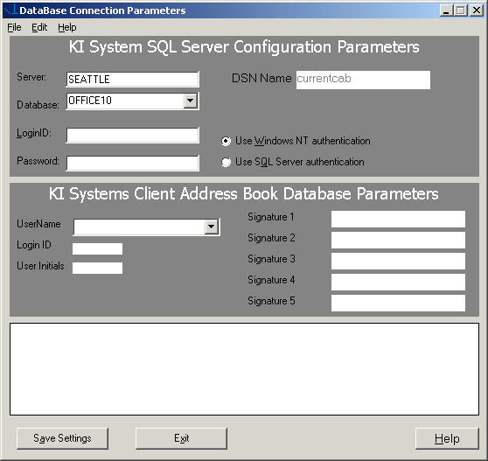
- The server name, database name and DNS name will already be filled in.
If you are the using Windows NT Authentication, you will not need to fill in the LoginID and Password information. If your firm uses SQL Server Authentication, the LoginID must match the LoginID in the screen below. See your Systems Administrator if you have questions. For the most part, you will not need to make any changes to the SQL Server Configuration Parameters.
- Proceed to the Client Address Book Database Parameters
- Select a name from the drop down menu in the LoginID area.
- If you select a name that is not the first name to appear in the signature block area, the following message appears:
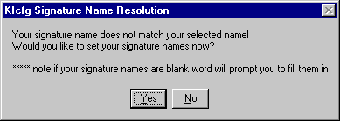
- Click Yes.
- The following screen appears:
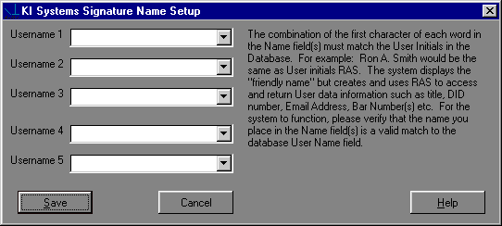
- Using the drop down menu, select the names you want to appear for use when you run signature blocks in the customized software. Be sure to select as the first name, the user name as in the Client Address Book Parameters screen.
- Click Save when you are done.

Forms Bank Organizer

Overview
The Forms Bank Organizer provides a user friendly interface that allows immediate access to form or brief bank information from Microsoft Word. It combines the efficiency of a database search engine with the automation and rich text capabilities of Microsoft Word. The Forms Bank Organizer gives you the flexibility to create, manage and automate your firm’s document creation processes using forms or a brief bank.

Forms can consist of:

- Standard Text.
- Automated Text via Word Merge Fields (Fill-in fileds)
- Automated text via Word Form fields – Standard.
- Automated text via Word Form fields - Protected.
- Custom Forms automated via Word Basic macros or Word Visual Basic for Applications macros.

Forms Organizer features include Quick Search, Advanced Search, and categorization of forms by type, descriptive name or author.

Create a Standard Text Form
- Type the text of your form in Word, formatting the text as it will appear in the document.
- If the form is going to be inserted into the current document, save it as a Word DOC (document.) If the form is going to be launched as a new document, save it as a Word DOT (template.)
- Move the form to the shared network forms directory. Create the database entry in the KI Admin Tool.

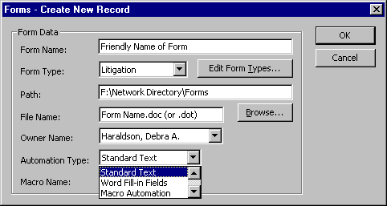

- Select Standard Text as the Automation Type for Fill-In field forms.

Create a Form with Fill-In Fields
- Type the text of your form in Word, leaving a * (asterisk) at each location where user will be providing Fill-In information.
- Create a Fill-In field at each * location as follows:
- Delete the *.
- In the”Prompt” text box, type the text of the prompt you would like the user to see. Enclose the text in quotes, as in the example below:
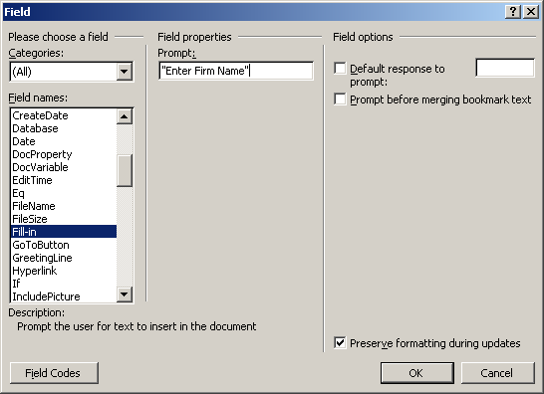
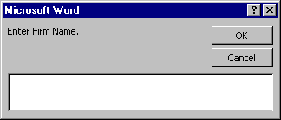
- When you click on OK, a sample of the Fill-in will show on the screen.
- DO NOT ENTER INFORMATION IN THE SAMPLE FILL-IN BOX WHEN IT POPS UP!
- Click on OK to continue.
- To edit Fill-in prompts, turn field codes on. (Tools, Options, View, Field codes.) Click on the check box next to Field codes to turn codes on.

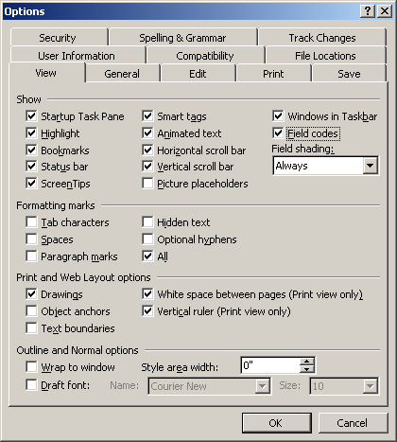

For each Fill-In field, you should see text in the following format:
{FILLIN “Enter Firm Name.” \* MERGEFORMAT}
The text enclosed in quotes represents the prompt users will see when running the form. You may edit the text by simply typing in your changes.

You may format the field as you would any word text. Select the entire field, then apply formatting (e.g., ALL CAPS, Bold, Underline.) The text typed in by users will be formatted accordingly in the completed document.

- If the form is going to be inserted into the current document, save it as a Word DOC (document.) If the form is going to be launched as a new document, save it as a Word DOT (template.)

- Move the form to the shared network forms directory. Create the index entry in the KI Admin Tool.

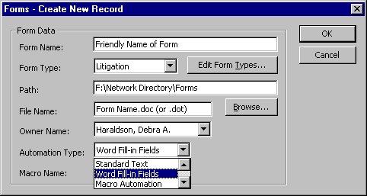

- Select Word Fill-in Fields as the Automation Type.

Create a Form with Form Fields – Standard or Protected
- Type the text of your form in Word, leaving a * (asterisk) at each location where Form Field will be inserted.
- Click on View Toolbars Forms to view the Forms toolbar.
- Create a Form field at each * location as follows:
- Delete the *.
Text Form Fields: Click on the “ab” button on the Forms toolbar. Double-click on the field to get the Properties Box. Complete the options in the dialog that appears on the screen

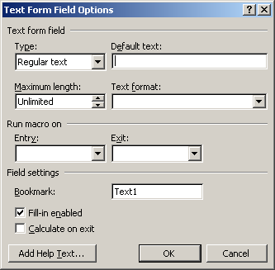

Check Box Form Fields: Click on the checkmark button on the Forms toolbar. Double-click on the field to get the Properties Box. Complete the options in the dialog that appears on the screen.
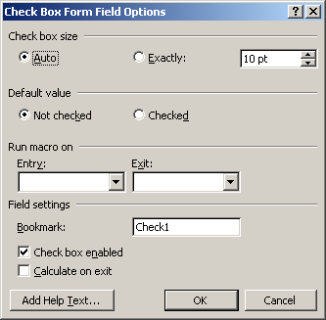

Drop-Down Form Fields: Click on the drop-down button on the Forms toolbar. Double-click on the field to get the Properties Box. Complete the options in the dialog that appears on the screen.

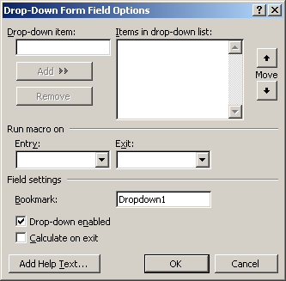

4. If the form is going to be inserted into the current document, save it as a Word DOC (document.) If the form is going to be launched as a new document, save it as a Word DOT (template.)
- Move the form to the shared network forms directory. Create the index entry in the KI Admin Tool.

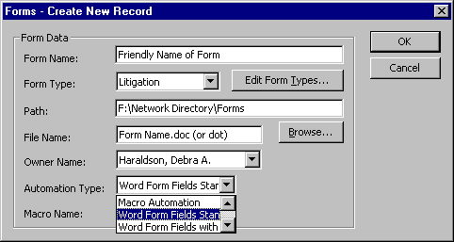

- Select Word Form Fields Standard as the Automation Type for Form Field forms.
- Note: When you use this type of form, as you tab past the very last form field in the document, the full document will become unprotected. The user may then edit the full text of the document.
- Select Word Form fields with protection (last item), as the Automation Type for Form Fields forms.
Note: When you use this type of form, as you tab past the very last form field in the document, you cycle to the first form field. This document will remain in the ‘Protected’ state. Users may not edit the main body text of a protected Form Bank document.

Create a Macro Form
- Type the text of your form in Word, formatting the text as it will appear in the document.
- Word 97’s programming language is Visual Basic for Applications. Development of forms using Macro Automation will require an advanced understanding of Word and at least some understanding of macro programming in Word Basic (Word 7.0 programming language) or Visual Basic for Applications. Macro Automation can be achieved through Macro Record commands, however creating dialog boxes to receive user input and insert into forms can be challenging for novice programmers.
- If the form is going to be inserted into the current document, save it as a Word DOC (document.) If the form is going to be launched as a new document, save it as a Word DOT (template.)
- Move the form to the shared network forms directory. Create the index entry in the KI Admin Tool.
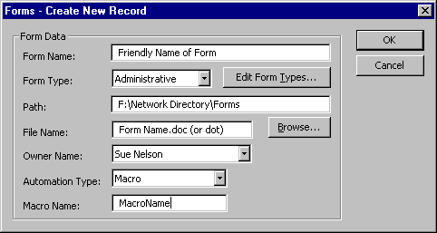
- Select Macro as the Automation Type for Macro forms. Enter the name of the macro that will execute your code in the Macro Name box.

Logo Builder

Overview
Often company information will change - whether it is a new address, new firm name, new zip code, new area code, different fax number, etc. We are often asked if KI Systems must modify the templates if this occurs. The answer most often is – no. KI Systems’ Law Office Automation Tools 2003 - Business Pak includes several Logo Builder documents. These documents allow you to:

- Create/Modify the stylized firm logos used in Business Pak templates
- Stylized logos can include formatted text and/or graphics
- The Stylized logos are stored within the Address Book database and are retrieved by the templates and inserted into new documents.
- Because stylized logos are stored in the database, no desktop modification of Autotext entries or desktop templates are needed to update this information.

Important note: If a logo(s) contains graphical images, the images should not exceed 75 KB in size for optimal performance.

Logo Builder
The Business Pak includes the following stylized logo documents:

- Letter Logo
- Personal Letterhead Logo
- Memo Logo
- Fax Logo
- Envelope Logo
- Label Logo
- Personal Envelope Logo
- Pleading Logo

Your customized version may include additional Logo Builder documents. At installation time, the Logo Builder documents will contain your firm’s settings, fonting, layout and graphics requested in the Business Pak Workbook.

Logo Builder documents should not be distributed to user Workstations. Only administrators or those individuals assigned the task of maintaining office logo information should have access to these files.

Warning: When information in the Logo Builder documents are modified and saved – this will globally take affect on all users’ workstations. Please ensure that any modifications you make are correct before saving changes in the Logo Builder documents.

Modifying Stylized Logos
The following steps outline the process to change and/or modify company information and logo formatting for the Business Pak templates:

- Load the KI Admin Tool
- From the Company Tab, modify the existing site entry as desired and press Save
- Open MS Word 2003
- Open the desired Logo Builder document.
- The Logo Builder process will prompt you to select the Office Location for which you wish to make modifications.

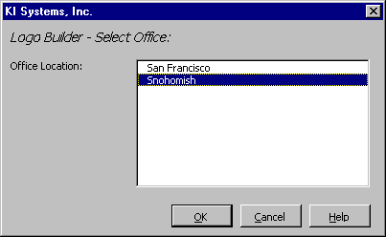

Note: The Office Location list may have one or many sites, depending on your firm.

- The Logo Builder document opens with the current Logo Layout for the template type (i.e. Letter).
- If changes have been made to the Company Information contained in the KI Admin Tool – OR – if your logo contains additional text not stored in Company Information (i.e. “Telephone: ” or “Facsimile: ”before office phone numbers) – OR – if your logo contains graphic file(s). You will see the following prompt:

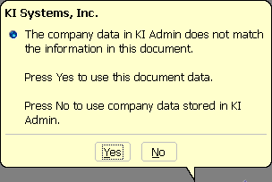

- If the modifications are minor and you wish to retain most the current stylized logo format, click “YES”
- If your stylized logo contains a graphic, click “YES”

- If you would like to start from scratch (with only the information from the Company Information tab, click “NO”
- With the stylized logo on the screen, make the desired modifications. Warning: Your Logo Builder documents have been sized to match the available space in the corresponding Business Pak template(s). Do not change the page setup/size of the Logo Builder document. Do not allow your changes to extend to more than one page.

- You may modify text, font and paragraph attributes. We recommend that your use direct character formatting – rather than styles in Logo Builder documents.
- Review your modifications and click on “Set Logo Modifications”
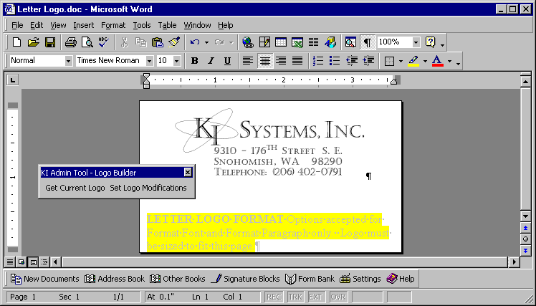

- To verify changes have been saved to the database, press Ctrl+A to select all text in the Logo Builder document and press Delete.
- Click on the “Get Current Logo” button and the stylized logo information will reappear in the Logo Builder document.
- Verify that all information is correct then save the final changes to the Logo Builder document.

All desktops will now use the updated Logo information. Repeat the above steps for each Logo Builder document type.

Note: Firms may need KI Systems assistance to modify template layout attributes if the look of the firm’s logo has significantly changed.

MAPI Connector

Overview
Address Book MAPI Connector provides access to your Address Book data from other mail applications such as Microsoft Outlook.

Add KI Systems Address Book To your mail profile

- Click Start, Control Panel, Mail.
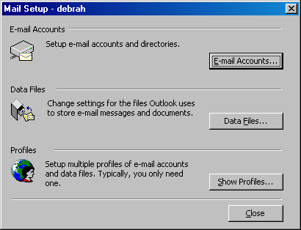

- Click E-mail Accounts.
  - Click Add a new directory or address book.

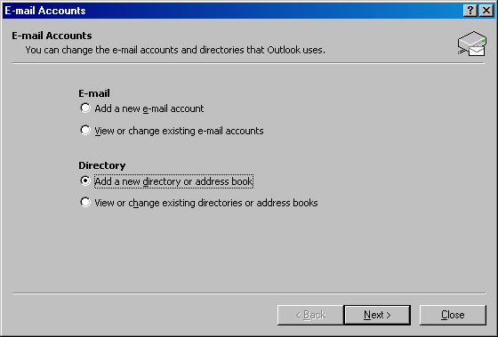

- Click Next.

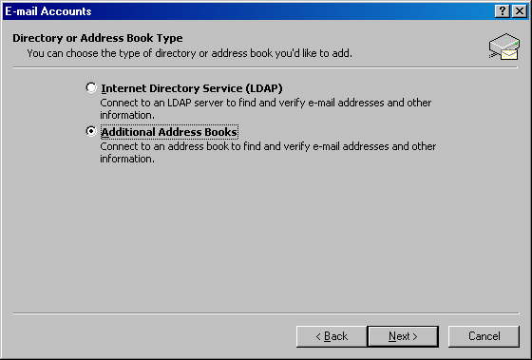
  - Click Additional Address Books.
  - Click Next.

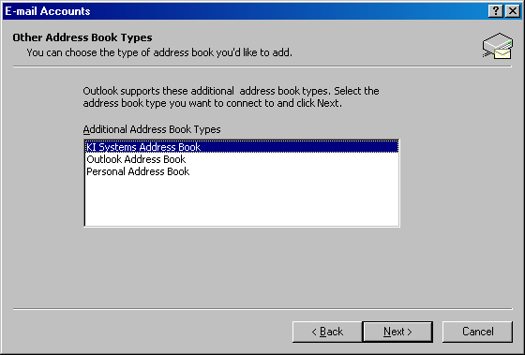
- Highlight KI Systems Address Book.

- Click Next to finish.

Outlook Address Book(s)
- Launch Outlook.
- To gain access to the emails in the Client Address Book, click on the Address Book button in the toolbar or click Tools, Address Book.
- The default Address Book will appear.
- Click the “Show names from the” drop-down box and select “Firm email contacts.”

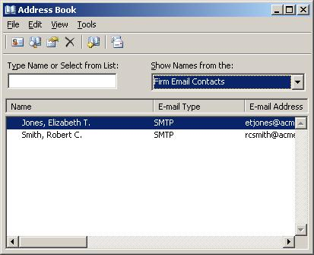

Note: Only records containing email addresses will appear in the list.

- To add an email address to a record in the Client Address Book, search for the record, click the Address tab then the Email button.

Remote Version

Overview
Take your office on the road! KI Systems Address Book – Remote Version give users away from the office the same features that are available to network users.
This includes the ability to:
- Access the firm’s Address Book contact information while “On the Road.”
- Create Documents using the same process used in the Office.
- Track creation of new Address Records and modifications to existing records while “On the Road.”
- Synchronize the “On the Road” Address Book modifications with the network database.

Go Mobile
To download the records that you own from the Network Client Address Book database to your local machine using Remote Version 2003.
Run Remote Version 2003.
- The following screen will appear:

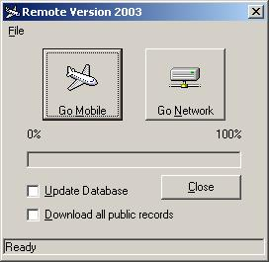

- Click the Update Database check box
- Click Go Mobile
- In the message bar at the bottom, you will see the message “Mobile Database Updated.”
- Click Close

Go Network
While working in remote mode, you can add, modify and delete client records to your local database. When you are back in the office and want to upload your records to the network Client Address Book database:

Run Remote Version 2003.

- The following screen will appear:

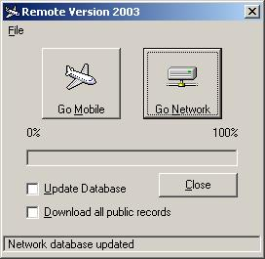

- Click the Update Database check box
- Click Go Network
- In the message bar at the bottom, you will see the message “Network Database Updated.”
- Click Close
Important notes:

Always select the ‘Update Database’ check box when you wish to keep the Network & local Databases synchronized. If you do not select the Update Database check box, only the database connection is re-targeted. No updating of records will take place.

When Selecting ‘Download all public records’, the entire contents of the firm Database will be transferred and is not user specific. Warning – This option involves all records in the database and depending on the size of your Database may take a considerable amount of time and system resources.

Outlook Synchronizer

Overview
The Outlook Synchronizer provides intelligent, one-touch synchronization of Enterprise Address Book Owner List contact information with Microsoft Outlook Contacts. The synchronization process mirrors the user's Enterprise Address Book Owner List contact into Microsoft Outlook Contacts.

With the user's Owner List in Microsoft Outlook, synchronization between the widest range of mobile devices and PC software applications is now available. Users can synchronize their Owner List from Outlook to Palm Pilot, a large number of Microsoft Windows® CE-based devices, and the latest smart phones and pagers.

Outlook Synchronizer is a bi-directional synchronization tool. The user's Owner List is mirrored to Outlook Contacts, and Outlook Contacts are mirrored back to the user's Owner List.

This bi-directional support allows users to create and update contact data using the application or hand held device of their choice. The Outlook Synchronizer provides flexible control over the synchronization process.

The user may select from a variety of synchronization "Rules." Rule Options include:

- Enterprise Address Book wins
- Outlook Contacts wins
- Microsoft Outlook wins based on the last modified date of the Outlook Contact record
- Allow the user to decide on a record by record basis

Recommendations Before you run the Outlook Synchronizer
Please consider the following before you execute the Outlook synchronization program (please give these instructions to your users.)

Background: In Address Book, the records that will be synched into Outlook then to a palm device, are those that you actually "own". The name in the "created by" in the Address tab of a record is the "owner" of that record. If a secretary has been entering names for an attorney, the secretary is the owner. To transfer ownership, she would locate the record, click Address, Owners. She would highlight the attorney's name and move to the Record Owners list. Once the attorney is the owner of the records, proceed to the following instructions.

If you have entries in the palm device that you want to be in the Address Book, you must synchronize with Outlook Contacts using the palm device software. If you have not installed this software yet, do so before proceeding.

- Using our synchronizer, synch outlook contacts with Address Book.
- Open Address Book and delete any duplicates owned by that owner.
- Open Outlook and delete all of your Outlook contacts.
- Synchronize Address book with Outlook
- Synchronize Outlook with palm device.
- You will not have to go through this delete function again. You can synch back and forth at will once the duplicates have been removed.

Using KI Outlook Synchronizer
- Run Outlook Synchronizer
- The following screen appears:
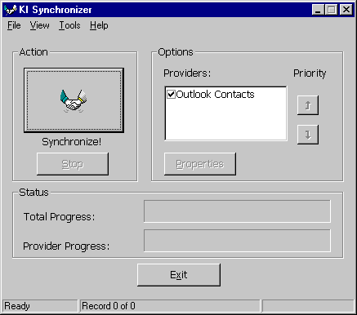

- In this example, the only provider present is Outlook Contacts.

- Click on the provider you want and click Properties.

- The following screen appears:
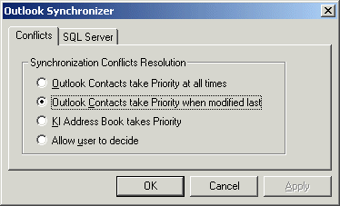
- Select the Synchronization Conflicts Resolution that best fits your needs.
- Click on the SQL Server tab.
- The following screen appears:

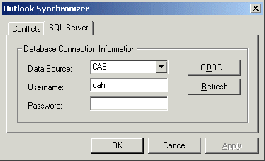

- In this example, the data source name is CAB. Check with your Systems Administrator for the correct Data Source name for your firm. If this information is filled in already, chances are it is correct.

- Click OK.
- Click the Synchronize button.

- The following screen appears:

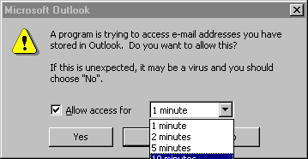

- It is recommended that you set the access time to the maximum of ten minutes.

- The records owned by you will now appear in the firm's Address Book and your Outlook Contacts list. To download your contacts to a hand-held device, use the manufacturer's software.
Contact Information:
Thank you for choosing KI Systems. If you have questions or need assistance with your software, please feel free to contact us:

KI Systems, Inc.
9310 – 176th ST SE
Snohomish, WA 98296
Tel. 425-402-0791
Fax 360-668-9864

e-mail: kristil@kisys.com
web site: www.kisys.com



