Remote Version

Take your office on the road! KI Systems Address Book – Remote Version give users away from the office the same features that are available to network users. This includes the ability to:

- Access the firm’s Address Book contact information while “On the Road.”
- Access the firm's Database information for Office Location, Logos, System Settings and Employee information.
- Create Documents using the same process use in the Office.
- Track creation of new Address Records and modifications to existing records while “On the Road.”
- Synchronize the “On the Road” Address Book modifications with the network database.

Mobile Workstation Setup

On each Mobile Workstation (Laptop) do the following:
- Install the network version KI Systems Law Office Automation tools while the Mobile Workstation is connected to the network.
- Double click on the Remote.exe file on the CD.
- The Welcome screen appears.

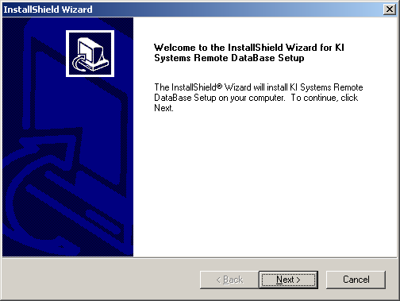

- Click Next.
- The license agreement screen appears.

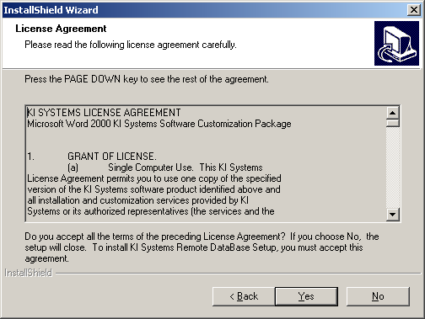

- Please review the terms and if you accept the terms press Yes to continue the installation.

- The “InstallShield Wizard Complete” screen appears.

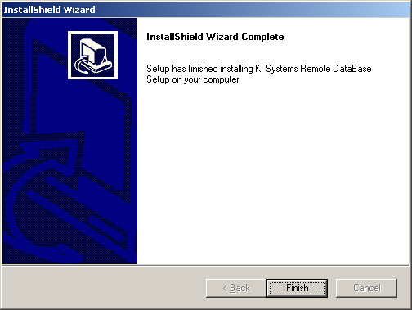

- Click Finish.
- The setup program has created a shortcut on your Start Menu, located under Programs, KI Systems called "KI Systems Remote Database Synchronizer." You may also wish to create a Desktop shortcut to the application. The target path for your desktop shortcut is: C:\Program Files\KI Systems\CABSYNC.EXE.
- Run the Remote Version application.
- Select "Update Database" and "Go Mobile" to populate the Remote Version database with data from your SQL Server database.
- Select "Go Network" to re-set the user to a Network mode connection.

Setup is now complete. The remaining sections of this manual are intended as a user guide for the Remote Version application.

Remote Version Overview

The Remote Version is a very simple application with two primary options – Mobile mode and Network mode. These modes can be used in combination with the additional options of "Update Database" and "Download all public records."

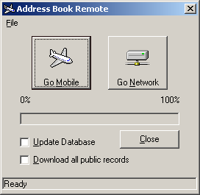

"Update Database" and "Go Mobile" – directs the application to populate the Mobile mode database with current data from your SQL Server database. Data includes:

- Contact Records where the user is the "Originator" or an assigned "Owner."
- System Settings for the templates and macros, including Office Location, Logos and Dictionary data.
- Logged in Employee data and preferences.

"Download all public records." and "Go Mobile" – directs the application to populate the Mobile mode database with current data from your SQL Server database. Data includes:

- All Public Contact Records contained within the Address Book
- System settings for the templates and macros, including Office Location, Logos and Dictionary data.
- Logged in Employee data and preferences.

NOTE: The download of "All Public Contact Records" may be a time consuming process if the number of Contact records contained within your SQL Server database is large.

"Update Database" and "Go Network" – directs the application to populate the network SQL Server database with New or Updated data from your Remote Version database. Data includes:

- Contact Records are Created or Updated where the user is the "Originator" or an assigned "Owner."

"Download all public records." and "Go Network" – directs the application to switch to Network mode only. This option setting does not transfer data.

"Go Mobile" with no additional option settings – directs the application to switch to Remote mode only. This option setting does not transfer data.

"Go Network" with no additional option settings – directs the application to switch to Network mode only.

Before You Leave the Office

Before you go “On the Road” perform the following:

- While connected to the network, close all Microsoft Office applications (Word and Outlook.)
- From your desktop shortcut or the Start Menu item, run the KI Systems Remote Database Synchronizer application
- If you wish to retrieve the current Address Book contact records and System Settings from the Firm’s SQL Server database – check the “Update Database” option
- Click the “Go Mobile” option

This process will place a copy of Address Book contact records and System Settings in a Microsoft Access database located on your local hard drive. It will also modify your workstation system settings to redirect your workstation to access to the local database.

Once the process is complete, follow your firm's standard procedures to log off from your network, disconnect your workstation, and you’re on your way.

When You Return to the Office

After you return “To the Office” perform the following:

- Follow your firm's standard procedure to log on and connect to your network.
- Close all Microsoft Office applications (Word and Outlook.)
- From your desktop shortcut or the Start Menu item, run the KI Systems Remote Database Synchronizer application.
- If you wish to update the network database with New or Updated contact records made while you were out of the office. – check the “Update Database” option
- Click the “Go Network” option

This process will update the Firm’s database with modifications you have made while “On the Road.” It will also modify your system settings to give you automatic access to the network database.

Once the process is complete, network access to the SQL Server database.

Security

The Remote Version application provides security for data transfer and updates.

For Contact records - the Remote Version “downloads” Address Book contact records for the user that is going “On the Road.” This provides a short list of contacts and not the firm’s full Address Book. The optional feature of "Download all public records" provides the full list of contacts. The application also provides verification on update that the remote user is authorized to update the firm’s Address Book contact record. Date and Time stamps both on the network and in the remote database are checked for accuracy of last updated by. Only the current edits are utilized and tracked.

For System Settings, such as Office Location, Logos, Employee information – the Remote Version "downloads" a copy of this information to the local database. This information is not transferred back or synchronized to the network SQL Server database.

Optional Configurations

For firms using Outlook, Lotus Notes, InterAction or Groupwise as their contact repository, the Remote Version product will provide data transfer of Office Location, Logos, Employee, and System Settings information from the SQL Server to the Remote Version database.

The "Update Database" option and "Go Mobile" should be selected as a user prepares to leave the office.

The "Go Network" option should be selected when a user returns to the office.

