TABLE OF CONTENTS

Form Bank Organizer 2
Overview 2
KI Admin Tool 2
Form Types 3
Create a Standard Text Form 4
Create a Form with Fill-In Fields 5
Create a Form with Form Fields 9
Create a Macro Form 13
To Use a Form From Form Bank 14

Form Bank Organizer

Overview
KI Systems’ Forms Bank Organizer is an add-on package for Microsoft Word. The Forms Bank Organizer provides a user friendly interface that allows immediate access to form or brief bank information from Microsoft Word. The Form Bank Organizer combines the efficiency of a database search engine with the automation and rich text capabilities of Microsoft Word.

The Forms Bank Organizer allows forms to consist of standard text, automated text via Word merge fields or custom forms automated via Word Visual Basic® for Applications macros. The Forms Bank Organizer gives you the flexibility to create, manage and automate your firm’s forms or brief bank processes.

Features include Quick Search, Advanced Search, categorization of forms by type, descriptive name or author. The Forms Pak includes an administration tool that makes forms management, updates and distribution a simple process.

Once you have installed this product, you can begin designing forms for firm-wide use. If you would rather have KI Systems create your forms for you, complete the appropriate forms located at the back of this workbook and return them to us.

KI Admin Tool
The KI Admin Tool is a comprehensive database management tool that allows your system administrator to easily modify Office Location, User Preference Settings, Forms Bank Organizer entries and database settings. Refer to the Systems Administration Guide to administer form bank entries.

Form Types
A standard text form is one with no prompts of any kind. It just contains text that, once called up from the Form Bank, will be inserted where the cursor is in the current document. A form with merge codes contains prompts that will stop on the screen and wait for the user to provide the information. The contents in this form will be inserted where the cursor is in the current document.

Another type of merge code document is one created with Form Fields. This type of form would be appropriate if the information requested requires more than just text, for example, a check box or a drop down menu from which to select certain information.

A more complicated form is one created using macros. This type of form is preferred if access to the firm’s address book is a requirement for completion of the form. Because a macro form can have more complicated user input screens, this type of form is much more versatile if the user needs to go back and forth between input screens. None of the other forms offer this flexibility.

Create a Standard Text Form

- Type the text of your form in Word, formatting the text as it will appear in the document.
- If the form is going to be inserted into the current document, save it as a Word DOC (document.) If the form is going to be launched as a new document, save it as a Word DOT (template.)
- Move the form to the shared network forms directory. Create the index entry in the KI Admin Tool.

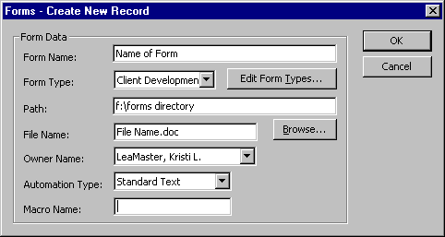

Select Standard Text as the Automation Type.

Create a Form with Fill-In Fields

- Type the text of your form in Word, leaving a * (asterisk) at each location where user will be providing Fill-In information.
- Create a Fill-In field at each * location as follows:
- Delete the *.
- Click on Insert Field. In the Field dialog box “Fill-in”.
- In the”Prompt” text box, type the text of the prompt you would like the user to see. Enclose the text in quotes, as in the example below:

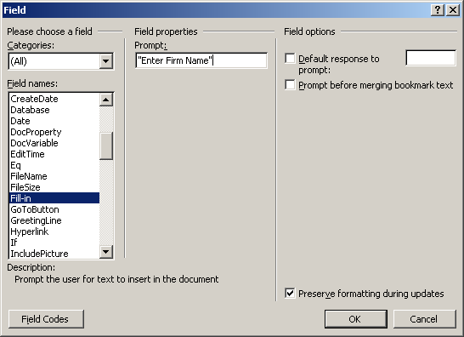

When you click on OK, a sample of the Fill-in will show on the screen:

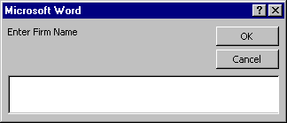

DO NOT ENTER INFORMATION IN THE SAMPLE FILL-IN BOX WHEN IT POPS UP! Click on OK to continue.
- To edit Fill-in prompts, turn field codes on. (Tools, Options, View, Field codes.) Click on the check box next to Field codes to turn codes on.

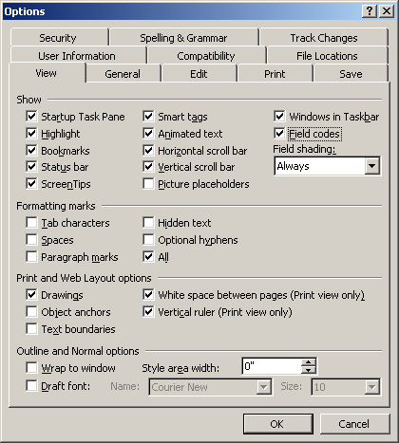

For each Fill-In field, you should see text in the following format:
{FILLIN “Enter Firm Name.” \* MERGEFORMAT}
The text enclosed in quotes represents the prompt users will see when running the form. You may edit the text by simply typing in your changes.

You may format the field as you would any word text. Select the entire field, then apply formatting (e.g., ALL CAPS, Bold, Underline.) The text typed in by users will be formatted accordingly in the completed document.

- If the form is going to be inserted into the current document, save it as a Word DOC (document.) If the form is going to be launched as a new document, save it as a Word DOT (template.)

- Move the form to the shared network forms directory. Create the index entry in the KI Admin Tool.

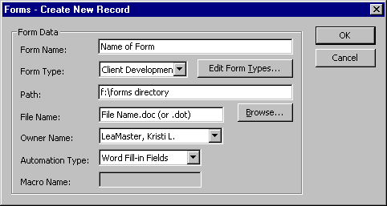

Select Word Fill-in Fields as the Automation Type.

Create a Form with Form Fields

1. Type the text of your form in Word, leaving an * (asterisk) at each location where Form Field will be inserted.
2. Click on View Toolbars Forms to view the Forms toolbar.
3. Create a Form field at each * location as follows:
- Delete the *.

Text Form Fields: Click on the “ab” button on the Forms toolbar. Double-click on the field to get the Properties Box. Complete the options in the dialog that appears on the screen.

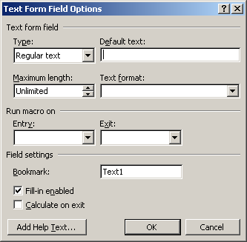

Check Box Form Fields: Click on the checkmark button on the Forms toolbar. Double-click on the field to get the Properties Box. Complete the options in the dialog that appears on the screen.

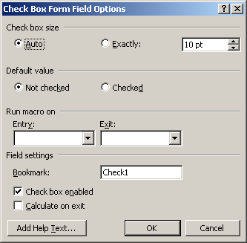

Drop-Down Form Fields: Click on the drop-down button on the Forms toolbar. Double-click on the field to get the Properties Box. Complete the options in the dialog that appears on the screen.

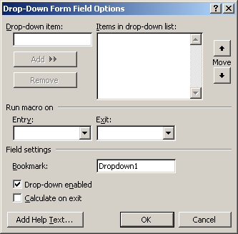

4. If the form is going to be inserted into the current document, save it as a Word DOC (document.) If the form is going to be launched as a new document, save it as a Word DOT (template.)
- Move the form to the shared network forms directory. Create the index entry in the KI Admin Tool.

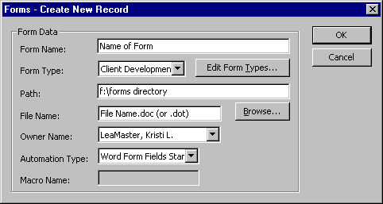

Select Word Form Fields Standard as the Automation Type.

Note: When you use this form, you must tab past the very last form field, whether filled in or not, to unprotect the form for future editing.

Create a Macro Form

- Type the text of your form in Word, formatting the text as it will appear in the document.
- Word’s programming language is Visual Basic for Applications (VBA). Development of forms using Macro Automation will require an advanced understanding of Word and VBA. Macro Automation can be achieved through Macro Record commands, however creating dialog boxes to receive user input and insert into forms can be challenging for novice programmers.
- Save the form as a Word DOT (template) file.
- Move the form to the shared network forms directory. Create the index entry in the KI Admin Tool.

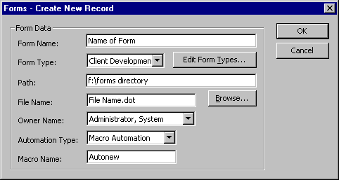

Select Macro as the Automation Type and Autonew as the Macro Name.

To Use a Form From Form Bank

- Click on the Macros button.
- Select Form Bank Organizer from the menu.

A screen similar to the following will appear (the Accounting and Administrative menus have been expanded in this example):

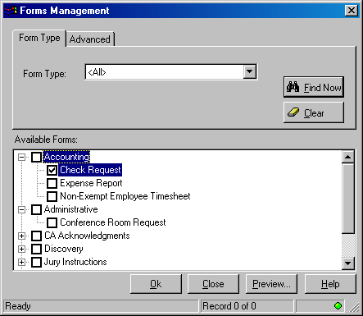

- Click in the check box next to the form you want to use. In the sample above, the Check Request form has been selected.
- Click OK and the form will run.

How the form runs depends upon what kind of form it is. A Standard Text form will insert text at the current cursor point. A form created with fields will allow you to enter text in the available fields. A form created using macros will have wizard screens for completing the text.

