KI Systems Numbering Tool – Installation Guide
KI Systems provides a wide range of enterprise software and services meeting the needs of Corporate and Legal.

Call us today at 425-402-0791
or visit our website at:
www.kisys.com
Table of Contents
Client Installation 1
To Install the Numbering Tool Software 1
To Use the Numbering Tool Software 4
To Un-Install the Numbering Tool Software 5

Client Installation

To Install the Numbering Tool Software
- Please close all Microsoft Office 2003 applications prior to the installation of the Numbering Tool.
- Use My Computer or Windows NT Explorer to access the KINUM.EXE setup file.
- If you have received the setup program as an attachment to email – save the attachments to your local workstation or network drive. Navigate to and run KINUM.EXE from your selected location and the install program will launch. Following InstallShield initialization, the following dialog will appear:
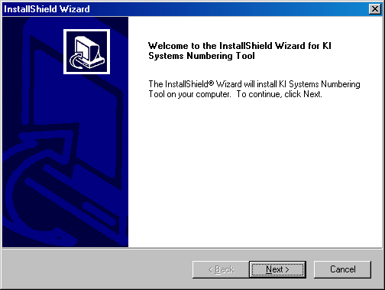

- Click Next to begin the Numbering Tool installation. The following dialog will appear:

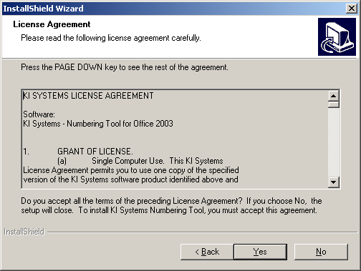

- Review the terms and conditions of the License Agreement and click Yes to accept and continue. The following dialog will appear:

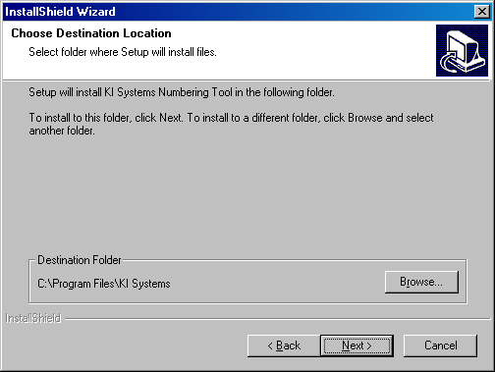

- You may select the default installation location or Browse to choose an alternate location. Please note: If you have other KI Systems software products installed on this workstation, this dialog will not appear and the additional Numbering Tool components will be installed into the existing location for our software products.
- The Numbering Tool installation process will begin.
- If the installation detects Microsoft Office 2003 components are running on the workstation, the following dialog box will appear:
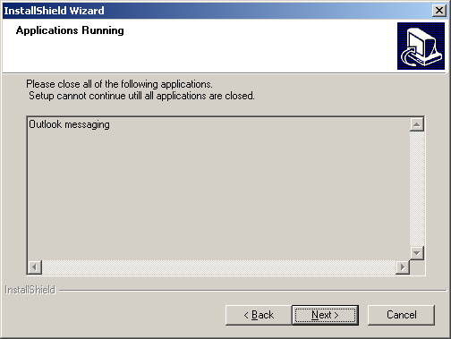

- Please close any listed applications and press Next to continue the installation.
- The following dialog will appear:
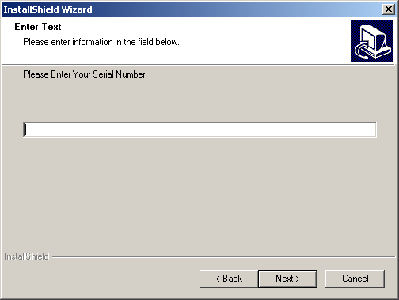

- Your product Serial Number can be found as an attachment to the email that accompanied your software installation program. The serial number is found at the end of the License Agreement or on the CD in the file “Notes.txt.” If you have received a 30-Day Demo version the software will expire on the 31st day following installation. Locate and enter the serial number provided.
- The software installation will proceed and will automatically end upon completion. There is no need to re-boot your workstation following the installation of the Numbering Tool software.
- When the installation has completed, launch Word 2002,
- At the bottom of Word’s screen, you will see a new toolbar.

To Use the Numbering Tool Software
A comprehensive “How To” help file is installed with the Numbering Tool Software. It can be accessed from the to olbar or any Numbering Tool dialog. The help file provides step by step instructions on using each feature of the Numbering Tool.
You may also refer to our web site http://www.kisys.com/Documentation%20Login.htm for the On-line Help Guide to learn how to use the KI Systems Numbering Tool. Please note: access to On-line Tech Notes, Documentation, Downloads, Tips & Tricks and Technical support requires user registration for an On-line ID. The On-line ID is free and provides you with a unique user login and password.

To Un-Install the Numbering Tool Software
- Click Start, Settings, Control Panel, Add/Remove Programs
- Locate KI Systems Numbering Tool and click Remove

