

MICROSOFT® WORD 2002

Remote Version

9310 – 176 th Street S.E.
Snohomish, WA 98296-5028
Telephone: (425) 402-0791

Remote Version

Take your office on the road! KI Systems Address Book – Remote Version give users away from the office the same features that are available to network users. This includes the ability to:

- Access the firm’s Address Book contact information while “On the Road.”
- Create Documents using the same process use in the Office.
- Track creation of new Address Records and modifications to existing records while “On the Road.”
- Synchronize the “On the Road” Address Book modifications with the network database.

Mobile Workstation Setup

On each Mobile Workstation (Laptop) do the following:
- Install the network version KI Systems Law Office Automation tools while the Mobile Workstation is connected to the network.
- Double click on the Remote.exe file on the CD.
- The Welcome screen appears.

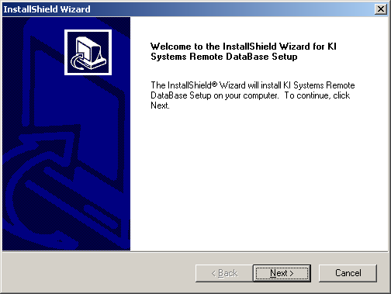

- Click Next.
- The license agreement screen appears.

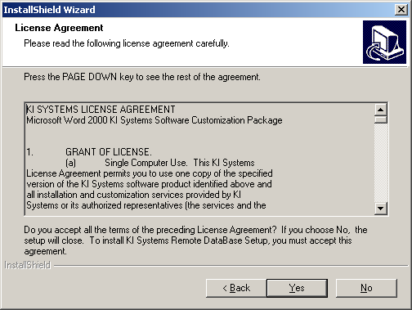

- Please review the terms and if you accept the terms press Yes to continue the installation.

- The “InstallShield Wizard Complete” screen appears.

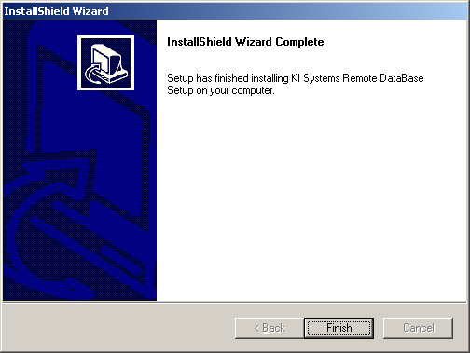

- Click Finish.
- Create a Desktop shortcut to C:\Program Files\KI Systems\CABSYNC.EXE
- Run the CABSYNC application

The Synchronizer (CABSYNC) application is a simple application. Click on the "Go Mobile" button to download the user’s contacts to the local database. Click on "Go Network" to upload the user’s contacts to the network database.

Only those contact records where the user is the “Originator” or an assigned “Owner” of the record will be downloaded/uploaded between the network and local databases.

Before You Leave the Office

The Address Book – Remote Version includes the Synchronizer application.
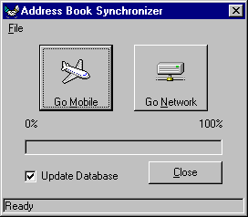
Before you go “On the Road” perform the following:

- While connected to the network with the mobile workstation
- From the Desktop shortcut, run CABSYNC
- If you wish to retrieve the latest Address Book contact records from the Firm’s database – check the “Update Database” option
- Click the “Go Mobile” option

This process will place a copy of Address Book contact records in a database on your local hard drive. It will also modify your system settings to give you automatic access to the local database.

Once the process is complete, disconnect from the network and you’re on your way.

When You Return to the Office

The Address Book – Remote Version includes the Synchronizer application.
After you return “To the Office” perform the following:

- Connect to the network
- From the Desktop shortcut, run CABSYNC
- If you wish to update the network with Address Book contact records from your local hard drive – check the “Update Database” option
- Click the “Go Network” option

This process will update the Firm’s database with modifications you have made while “On the Road.” It will also modify your system settings to give you automatic access to the network database.

Once the process is complete, network access to full contact information is restored.

Security

The Synchronizer application provides security for Address Book record transfer and updates. The Synchronizer only “downloads” Address Book contact records for the user that is going “On the Road.” This provides a short list of contacts and not the firm’s full Address Book. It also provides verification on update that the remote user is authorized to update the firm’s Address Book contact record. Date and Time stamps both on the network and in the remote database are checked for accuracy of last updated by. Only the current edits are utilized and tracked.

