

MICROSOFT® WORD 2002

Outlook Synchronizer

9310 – 176 th Street S.E.
Snohomish, WA 98296-5028
Telephone: (425) 402-0791

Table Of Contents

Overview 2
Features 2
Benefits 2
To Install 3
First Time Synchronizer Runs 4
To Synchronize 5

Overview
The Outlook Synchronizer provides intelligent, one-touch synchronization of Enterprise Address Book Owner List contact information with Microsoft Outlook Contacts.
The synchronization process mirrors the user’s Enterprise Address Book Owner List contact into Microsoft Outlook Contacts.

With the user’s Owner List in Microsoft Outlook, synchronization between the widest range of mobile devices and PC software applications is now available. Users can synchronize their Owner List from Outlook to Palm Pilot, a large number of Microsoft Windows® CE-based devices, and the latest smart phones and pagers.

Features
KI Systems Outlook Synchronizer is a bi-directional synchronization tool. The user’s Owner List is mirrored to Outlook Contacts, and Outlook Contacts are mirrored back to the user’s Owner List.

This bi-directional support allows users to create and update contact data using the application or hand held device of their choice.

The Outlook Synchronizer provides flexible control over the synchronization process.

The user may select from a variety of synchronization “Rules.”

Rule Options include:

- Enterprise Address Book wins
- Outlook Contacts wins
- Microsoft Outlook wins based on the last modified date of the Outlook Contact record
- Allow the user to decide on a record by record basis

Benefits

KI Systems Outlook Synchronizer provides Integration with Microsoft Office 2000

One-touch synchronization of Microsoft Outlook client data. Users can quickly synchronize their Enterprise Address Book contacts with Outlook 2000.

Enables Extended synchronization From Outlook contacts can be further synchronized with the palm computing platform as well as Microsoft Windows CE-based and other handheld devices.
Labor savings. One-touch synchronization to Outlook 2000 and Microsoft Exchange data saves data-entry time and keeps users current.

To Install
- Locate the setup program for KI Systems’ Outlook Synchronization. Consult your Systems Administrator if you have any questions.
- Double-click on the setup.exe file to begin the installation process. Follow the prompts on the screen.
The setup program will create a KI Systems folder in the Program Files directory and a KISynch folder within it. It is here where you will find the synchronization program.

First Time Synchronizer Runs

Note: You may want to create a shortcut to this program on your desktop so it is easily accessed. The executable is located in c:\program files\ki systems\kisync.exe.

Here are the steps to follow the first time you run this synchronization program (please give these instructions to every user):

Background: In Address Book, the records that will be synched into Outlook then to a palm device, are those that you actually "own". The name in the "created by" in the Address tab of a record is the "owner" of that record. If a secretary has been entering names for an attorney, the secretary is the owner. To transfer ownership, she would locate the record, click Address, Owners. She would highlight the attorney's name and move to the Record Owners list. Once the attorney is the owner of the records, proceed to the following instructions.

- If you have entries in the palm device that you want to be in the Address Book, you must synchronize with Outlook Contacts using the palm device software. If you have not installed this software yet, do so before proceeding.
- Using our synchronizer, synch outlook contacts with Address Book.
- Open Address Book and delete any duplicates owned by that owner.
- Delete all outlook contacts.
- Synchronize Address book with Outlook
- Synchronize Outlook with palm device.

You will not have to go through this delete function again. You can synch back and forth at will once the duplicates have been removed.

When you run kisync the next time, you will see a list (probably only one) under providers. Click on Outlook and click properties button. You need to make a decision on what "wins" when synching.

To Synchronize
- Create a shortcut to the Synchronization program if you like and double-click on it to launch the program.
- To run the synchronization program from Windows Explorer, locate the KISync.exe file in c:\program files\KI Systems\KISync folder and double-click on it.
- The following screen appears:

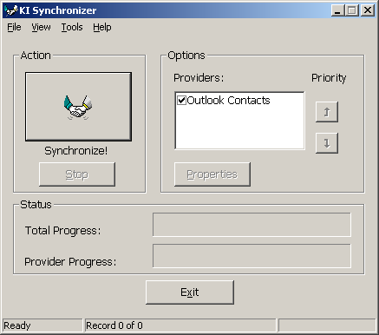

If you have more than one provider listed, you can use the up and down arrow buttons to prioritize them for synchronization. Highlight the provider and “promote” or “demote” it.

To set a rule for a provider, click on the check box and click on the Properties button.
The following menu appears:

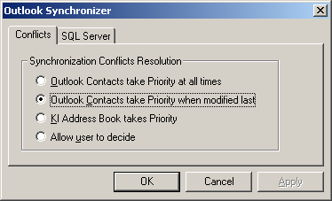
- Select the appropriate option and click OK.
- Click on the Synchronize! button.

Note: If you have installed Microsoft Outlook E-Mail security update, the synchronization program will halt and the following dialog box will appear:

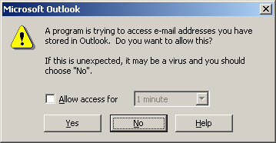

Click in the “Allow access for” check box and select an access time from the drop down box, then click Yes.

Also note that, for whatever reason, the “No” button does not work. If you want to halt the Synchronization process, click Yes in the above dialog box then click Stop in the Outlook Synchronization program.

You will see status bars move to the right in the Total Progress and Provider Progress areas as the program runs.

When the dialog box with “Synchronization complete” appears, the process is done. Click OK then click Exit.

You will now see your Contact List entries in the firm’s address book and the firm address book entries that list you as owner in your Outlook Contact List.

