Numbering Tool – Installation Guide
KI Systems provides a wide range of enterprise software and services meeting the needs of Corporate and Legal.

Call us today at 425-402-0791
or visit our website at:
www.kisys.com
Table of Contents
Client Installation 2
To Install the Numbering Tool Software 2
To Un-Install the Numbering Tool Software 6

Client Installation

To Install the Numbering Tool Software
- Please close all Microsoft Office XP applications prior to the installation of the Numbering Tool.
- Use My Computer or Windows NT Explorer to access the KINUM.EXE setup file.
- If you have received the setup program as an attachment to email – save the attachments to your local workstation or network drive. Navigate to and run KINUM.EXE from your selected location and the install program will launch. Following InstallShield initialization, the following dialog will appear:
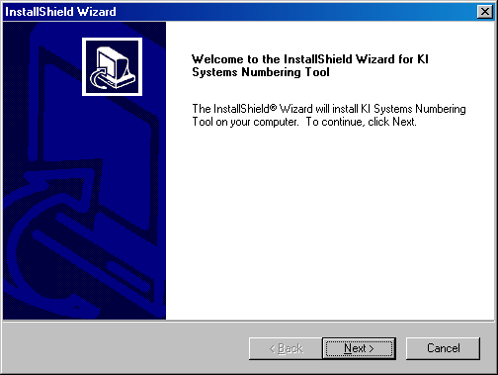

- Click Next to begin the Numbering Tool installation. The following dialog will appear:

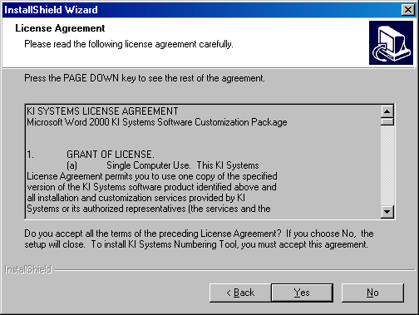

- Review the terms and conditions of the License Agreement and click Yes to accept and continue. The following dialog will appear:

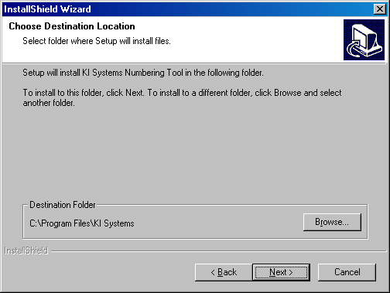

- You may select the default installation location or Browse to choose an alternate location. Please note: If you have other KI Systems software products installed on this workstation, this dialog will not appear and the additional Numbering Tool components will be installed into the existing location for our software products.
- The Numbering Tool installation process will begin.
- If the installation detects Microsoft Office XP components are running on the workstation, the following dialog box will appear:
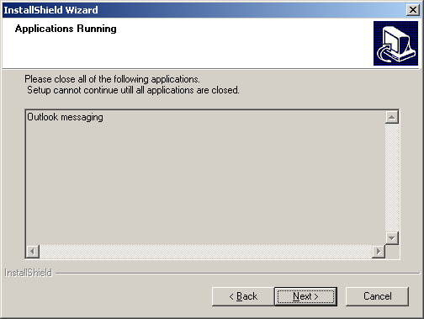

- Please close any listed applications and press Next to continue the installation.
- The following dialog will appear:
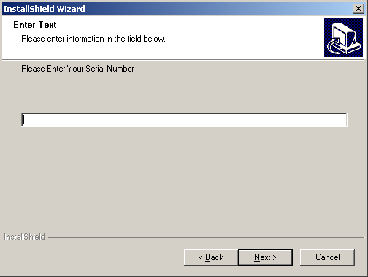

- Your product Serial Number can be found as an attachment to the email that accompanied your software installation program. The serial number is found in the file Notes.txt. . If you have received a 30-Day Demo version the software will expire on the 31st day following installation. Locate and enter the serial number provided.
- The software installation will proceed and will automatically end upon completion. There is no need to re-boot your workstation following the installation of the Numbering Tool software.
- When the installation has completed, launch Word 2002,
- At the bottom of Word’s screen, you will see a new toolbar.

To Use the Numbering Tool Software
Refer to our web site http://www.kisys.com/Documentation%20Login.htm for the On-line Help Guide to learn how to use the KI Numbering Tool. This page requires a login and password.

To Un-Install the Numbering Tool Software
- Click Start, Settings, Control Panel, Add/Remove Programs
- Locate KI Systems Numbering Tool and click Remove

