Metadata Tool – Installation Guide
KI Systems provides a wide range of enterprise software and services meeting the needs of Corporate and Legal.

Call us today at 425-402-0791
or visit our website at:
www.kisys.com
Table of Contents
Client Installation 2
To Install the Metadata Tool Software 2
To Use the Metadata Tool Software 5
To Un-Install the Metadata Tool Software 6

Client Installation

To Install the Metadata Tool Software
- Please close all Microsoft Office XP applications prior to the installation of the Metadata Tool.
- Use My Computer or Windows NT Explorer to access the KIMDSetup.EXE setup file.
- If you have received the setup program as an attachment to email – save the attachments to your local workstation or network drive. Navigate to and run KIMDSetup.EXE from your selected location and the install program will launch. Following InstallShield initialization, the following dialog will appear:
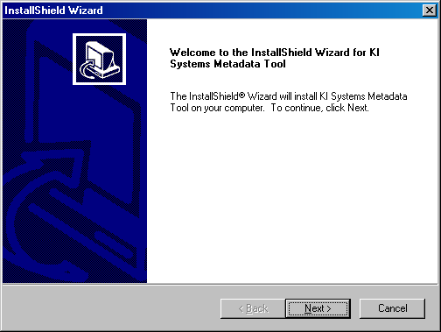

- Click Next to begin the Metadata Tool installation. The following dialog will appear:

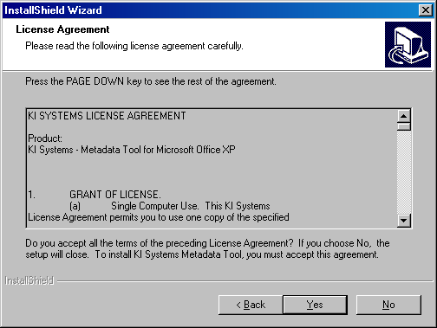

- Review the terms and conditions of the License Agreement and click Yes to accept and continue. The following dialog will appear:

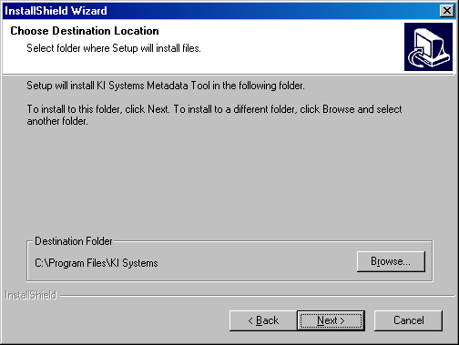

- You may select the default installation location or Browse to choose an alternate location. Please note: If you have other KI Systems software products installed on this workstation, this dialog will not appear and the additional Metadata Tool components will be installed into the existing location for our software products.
- The Metadata Tool installation process will begin.
- If the installation detects Microsoft Office XP components are running on the workstation, the following dialog box will appear:

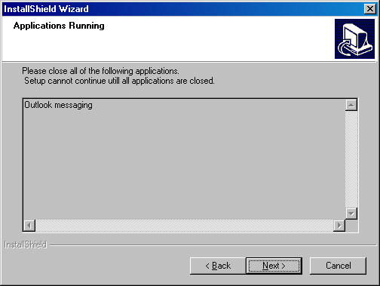

- Please close any listed applications and press Next to continue the installation.
- The following dialog will appear:
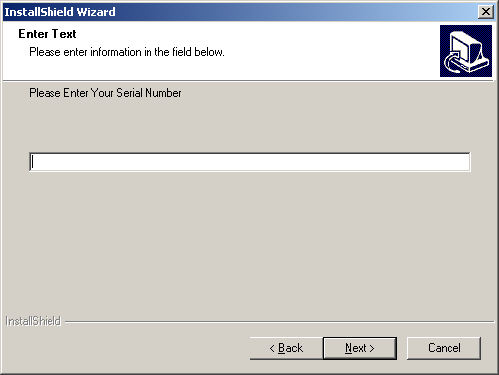

- Your product Serial Number can be found as an attachment to the email that accompanied your software installation program. The serial number is found in the file Notes.txt. If you have received a 30-Day Demo version the software will expire on the 31st day following installation. Locate and enter the serial number provided.
- The software installation will proceed and will automatically end upon completion. There is no need to re-boot your workstation following the installation of the Metadata Tool software.
- When the installation has completed, launch Word 2002,
- At the top of Word’s screen, you will see a new toolbar:
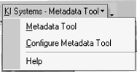
- Launch Outlook 2002, and a similar screen will appear:
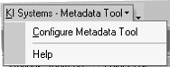
- Note: On send of an e-mail message that contains attachments – the Metadata Tool will prompt you to analyze and clean attachments of type .DOC, .DOT or .RTF depending on your configuration settings.
- Launch Explorer and right mouse click on one or many files and select the menu option “KI – Systems - Metadata Tool…” to analyze and clean the selected files:
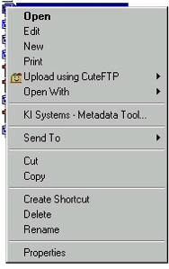

To Use the Metadata Tool Software
For additional use instructions, please refer to Help provided with our application or refer to our web site http://www.kisys.com/Documentation%20Login.htm for the On-line Help Guide for the Metadata Tool. Please note: this page requires an on-line login and password.

To Un-Install the Metadata Tool Software
- Click Start, Settings, Control Panel, Add/Remove Programs
- Locate KI Systems Metadata Tool and click Remove

