Installation Instructions for MSDE and
KI Systems Office Automation Tools
For Microsoft Office 97, 2000 and XP
Table of Contents
Introduction 2
System Requirements 3
Step 1 – MSDE Setup 4
Step 2 – Installing the Database – KI Server 8
Step 3 – Microsoft Word configuration to support KI Systems software. 15
Step 4 – Installing the Client – KIClient.exe 17
Step 5 – Configuring Workstation/User Access to the Database 22
Step 6 – Configuring Office Locations and Users 25
Step 7 – Accessing KI Systems Software from within Microsoft Word 29

Introduction
KI Systems software for your our Office Automation Tools for Microsoft Office 97, 2000 or 2002 is included on the enclosed CD. Installation screen shots may vary based on the version of our software purchased. Installation consists of four separate components:
- Server: Installation of Microsoft MSDE.
- Server: Installation of KI Systems’ server software
- Client: Installation of workstation software
  - Client Components included:
    - Microsoft Word Integration
    - Business Pak templates and macros
    - Pleading Pak templates and macros (optional component)
    - MAPI Connector (optional component)
    - Form Bank Organizer (optional component)
  - Administration Components included:
    - KI Administration Tool
    - KI Configuration Tool

System Requirements
  - Server software must be installed on a computer running Windows NT, Windows 2000 or Windows XP Professional operating system.
  - MSDE Server installation software assumes that there are no instances of Microsoft SQL server installed on the target server. If you have Microsoft SQL Server installed on the target server, DO NOT install KI System’s Server software. Contact KI Systems, Inc. at 425-402-0791 for site-specific installation instructions.
  - The server installation requires a total of 370 MB of drive space on your target server: 70 MB for MSDE installation and 300 MB for installation of KI Systems Address Book and your ported data.
  - The client installation assumes that the workstation has Microsoft Office 97/2000 installed and ODBC drivers for MSSQL Server version 3.70 or 2000. Microsoft Office XP requires the installation of Microsoft Data Access Components (MDAC) 2.7 or higher. Client installation drive space requirements vary from site to site but are generally 5-15 MB.

Step 1 – MSDE Setup
Note: Server should have 70 MB of drive space available to ensure a successful MSDE installation on the server’s C drive.
This installation must be performed on the file server or on a workstation running Microsoft Windows NT, Microsoft Windows 2000, or Microsoft Windows XP Professional where the database will reside.
- Insert the CD into the Server’s CD drive.
- From Explorer or My Network Places, select the CD Rom drive.
- Double click the Setup.exe file.
- The Welcome screen appears. Click Next.
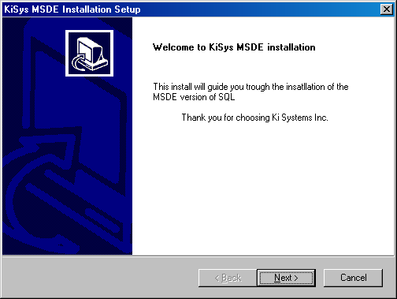
- The Path to install MSDE appears:
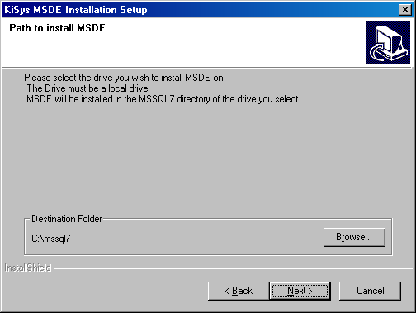
- Please select the drive you wish to install MSDE on. It must be a local drive on the server. MSDE will be installed in the MSSQL7 directory of the drive you have selected. Use Browse you need to change the drive:
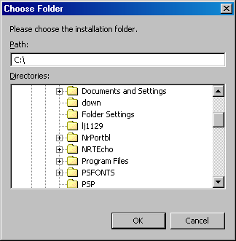
- Click Next.
- The following screen will appear:

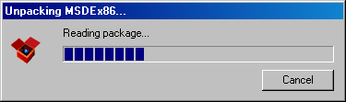
- The Setup Status screen will appear as NoWin is installed.
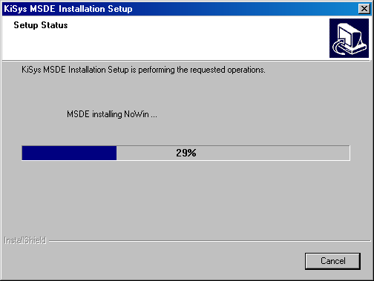
- The Setup Status screen will appear as MSDE is installed:
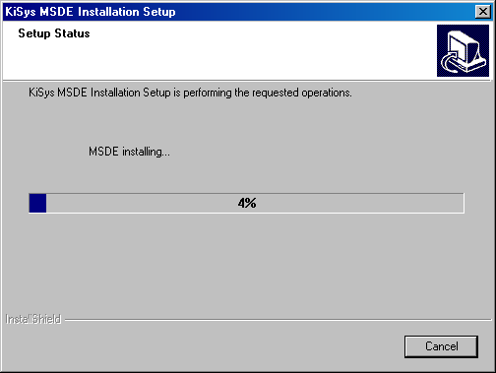

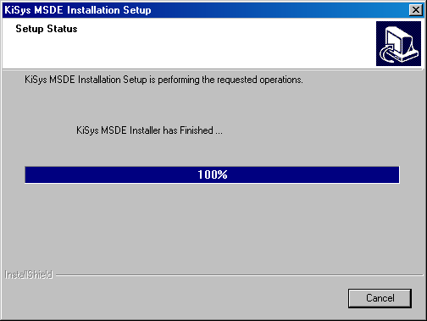
- When the installation has completed, reboot the server.

Step 2 – Installing the Database – KI Server
Note: Server should have 300 MB of free drive space available on its C drive to ensure a successful installation of KI Server.
This installation must be performed on the file server or on a workstation running Microsoft Windows NT, Microsoft Windows 2000 or Microsoft Windows XP Professional where the Microsoft SQL Server MSDE has been installed.
- Insert the CD into the Server’s CD drive.
- From My Computer, select the CD Rom drive.
- Double click the KIServer.exe file.
- The welcome screen will appear.
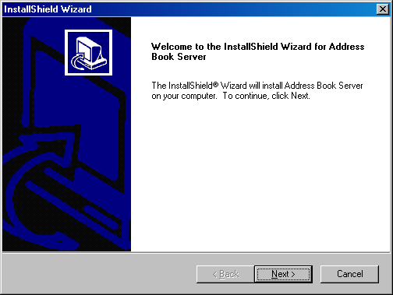
- Click Next.
- The license agreement will appear.
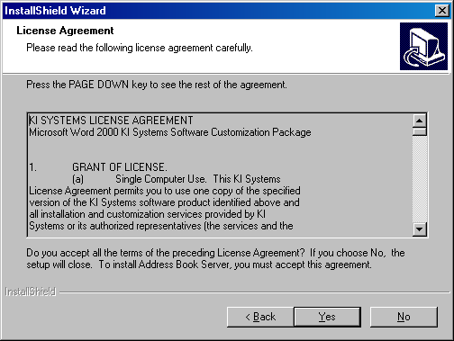
- Please review the terms and if you accept the terms click Yes to continue the installation.
- The SQL Server Login screen will appear.
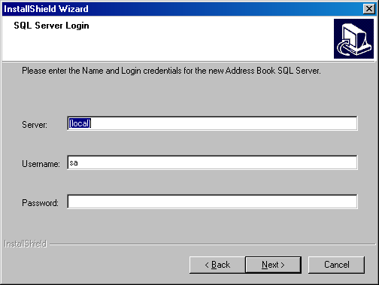
You are installing this program on the local machine, so the Server Name is set to “local’.
The User name is SA (for Systems Administrator)
If you have installed MSDE using KI Systems Setup.exe, the password for SA access is left blank.
- Click Next.
- The Destination Folder screen appears.
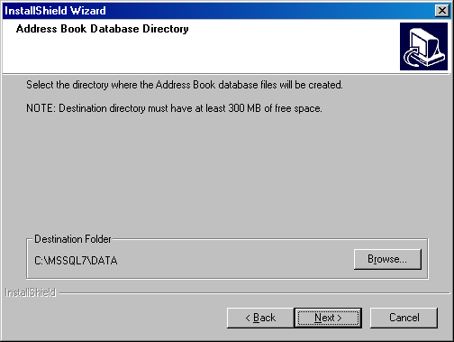
- Be sure the path is correct. (In this example, the path C:\MSSQL7\Data will be used.) Refer to the drive letter from step one and verify the path. Use Browse to select appropriate install location:
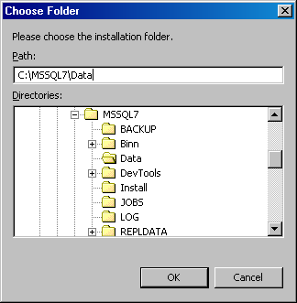
- Click OK when the drive has been selected.
- Click Next to continue.
- The Address Book data files screen appears.

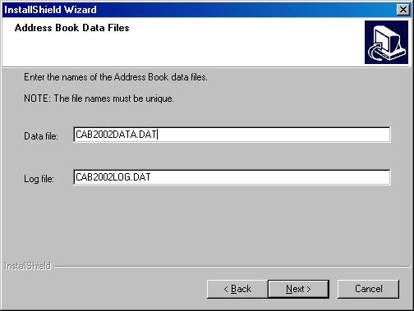
- Click Next.
- The Address Database Name screen appears.
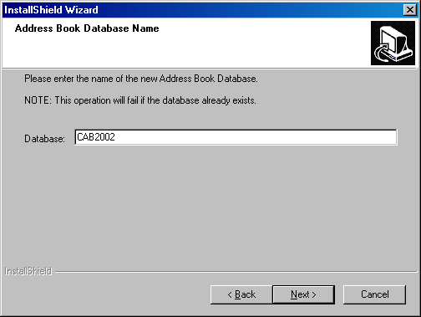
The Microsoft Office XP version of the KI Address Book is called “CAB2002”. If you have installed KIServer.exe previously, please use setup to un-install KI Server before re-installing the server setup program. There can be only one instance of a CAB2002 database registered with Microsoft SQL Server. If a CAB2002 database exists, this setup will fail.
The Microsoft Office 2000 version of the KI Address Book is called “CAB2000”. If you have installed KIServer.exe previously, please use setup to un-install KI Server before re-installing the server setup program. There can be only one instance of a CAB2000 database registered with Microsoft SQL Server. If a CAB2000 database exists, this setup will fail.
The Microsoft Office 97 version of the KI Address Book is called “CAB”. If you have installed KIServer.exe previously, please use setup to un-install KI Server before re-installing the server setup program. There can be only one instance of a CAB database registered with Microsoft SQL Server. If a CAB database exists, this setup will fail.
- Click Next.
- The Windows Domain Name screen appears.
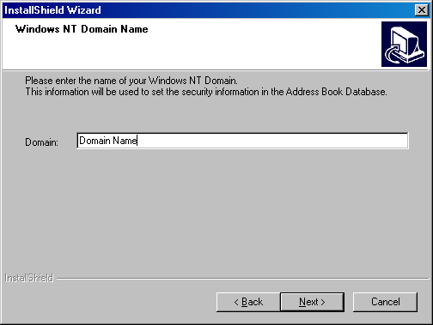
- Enter the Windows domain name.
- Click Next.
- A status bar will appear:
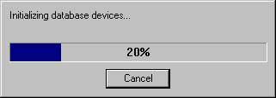
- When the installation has been successfully completed, the following screen appears:
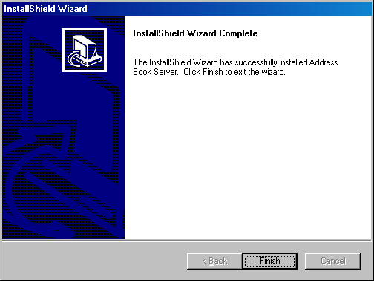
- Click Finish.

Step 3 – Microsoft Word configuration to support KI Systems software.
Before installing the KI Systems workstation software (KIClient.exe):
- Install the appropriate version of Microsoft Office software (97, 2000 or XP). Be sure to include the word processing application Microsoft Word 97, 2000, or 2002.
- Install and configure document management software (if appropriate). KI Systems software may be integrated to your document management software based on your License and Consulting Services Agreement.
- Launch Microsoft Word 97/2000/2002 and set the default paths as listed below. Be sure to navigate using the mouse to these various directories to ensure that the paths are correct. Upon opening the File Locations window, the paths are truncated and the appear to be correct but chances are they are not.
- Click Tools, Options, File Locations:
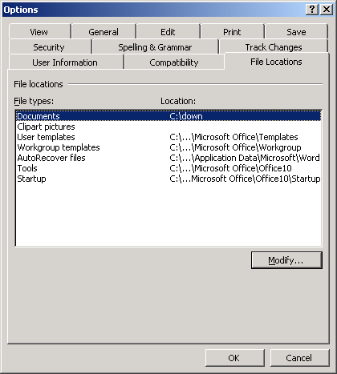
Documents path: Set to a network drive or local drive. Please note: a Registry key does not exist for this path until it is changed at least once within the Options dialog. The registry key setting must be present for KI Systems integration to function correctly.
User Templates: c:\program files\microsoft office\templates
Workgroup: c:\program files\microsoft office\workgroup
(If the workgroup folder does not exist, Setup will create it and set this path.)
Startup (Word 97/2000): c:\program files\microsoft office\office\startup
Startup (Word 2002): c:\program files\microsoft office\office10\startup
For Word 2002 only, an additional change to Word’s default security setting is necessary:
- Click Tools, Macro, Security
- Click on the Trusted Sources tab
- Click both check boxes at the bottom of this screen:
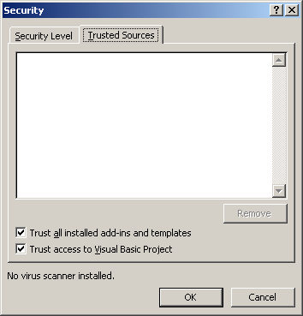
- Close Microsoft Word 2002.

Step 4 – Installing the Client – KIClient.exe
Close all Microsoft Office applications – including Microsoft Outlook.
- From Control Panel Add/Remove programs or run directly from the CD, execute the workstation client installation file (KIClient.exe).
- The welcome screen will appear.
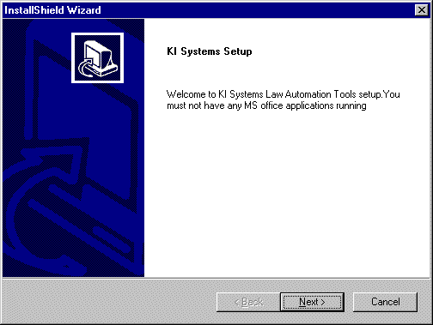
- Click Next
- The license agreement will appear.
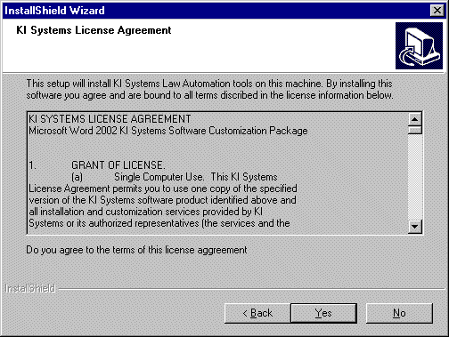
- Please review the terms and if you accept the terms, click Yes to continue the installation.
- The KI Systems File Location screen will appear.
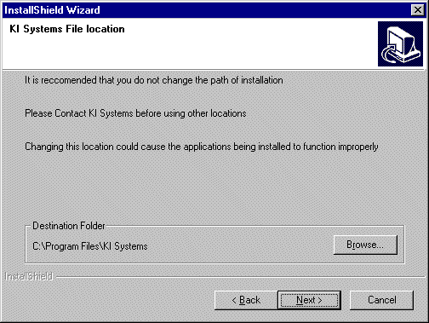
- To ensure application functionality – we recommend that you do not modify the target path. Click Next to continue.
- The serial number screen will appear.
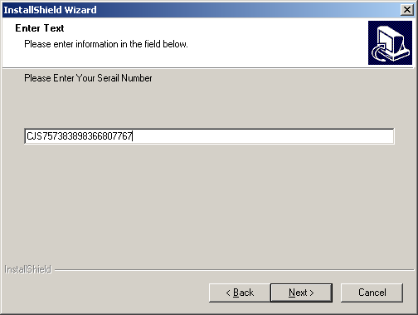
  - Your firm’s serial number can be found on the installation CD in the NOTES.TXT file. Open this file and enter the Serial Number. (Note: you may copy and paste the serial number from the Notes.txt file into the dialog box.) Click Next.
  - The Database Setup screen appears.
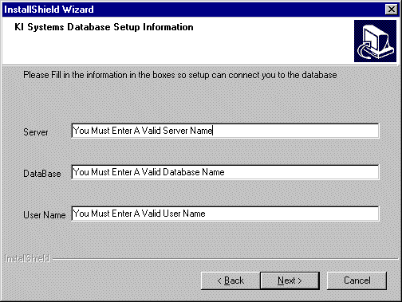
- Enter in the server, database and a valid user name. Click Next.
- The File Location screen appears.
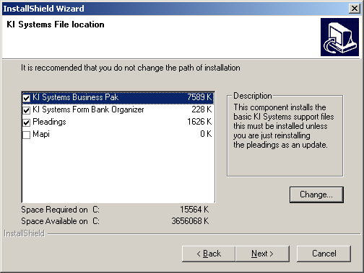
Refer to you Licensing Agreement for the proper number of licenses for all components purchased by your firm, and install these components accordingly. In the example above, the workstation is licensed for the Business Pak, Form Bank, and Pleading Pak. The Mapi Connector will not be installed on this workstation. Select the options for this workstation.:
- Click Next.
- The program will search for and rename the existing normal.dot to normal.old. The user can then copy any styles, autotext entries, or macros into the new normal.dot.
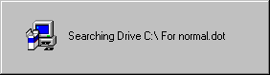
- This final screen will appear when the software is installing:
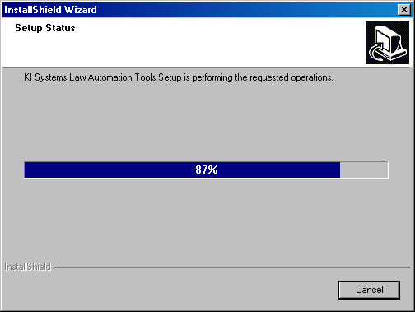
- When the above screen closes, the software has been successfully installed.

Step 5 – Configuring Workstation/User Access to the Database
Before accessing the newly installed KI Office Automation Tools on your workstation, you need to configure the logged in user to connect to the database. If you have installed the software as Administrator, please log in as the user assigned to the workstation. Database access requires registry key settings be placed in HKey_Current_User section of the Registry.
- Log in as the assigned User
- Click Start, Run
- Enter: kicfg
The following screen appears for CAB (Word 97), or CAB2000 (Word 2000):
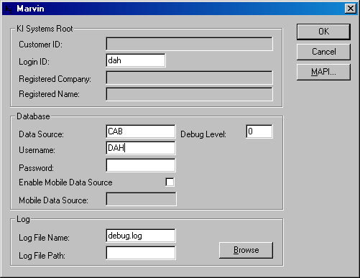
- Enter the Login ID and Username as it appears for this user in the KI Admin Employee Database.
- Enter “CAB” for Word 97, or “CAB2000” for Word 2000 in the Data Source field.
- Click OK.
The following screen appears for CAB2002:
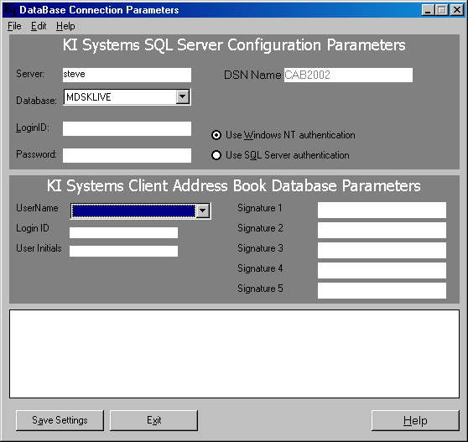
- Select the correct Database from the Database menu (CAB2002, CAB2000 or CAB).
- Select Use Windows NT authentication
- Please note special permissions to MSDE and the database are necessary if users are meant to connect via SQL Server authentication. Please contact KI Systems for the necessary permission scripts if they were not provided with the Server Installation files.
- Select a UserName from the UserName menu.
- Click Save Settings and the following screen appears:
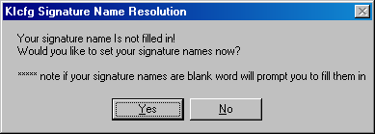
- Click Yes. The following screen appears:
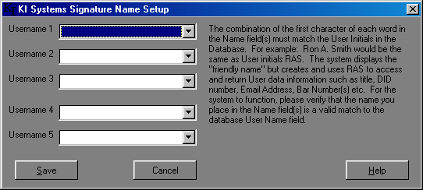
- Select at least one preference User Name for Signature Blocks or up to five preference User Names.
- Click Save
- Click Exit to end the KI Systems Configuration Tool (KICFG.exe).

Step 6 – Configuring Office Locations and Users
To configure, review or modify the local office and user settings in the MSDE database:
- Click Start, Run
- Enter: kiadmin
- Click OK and the following screen appears:
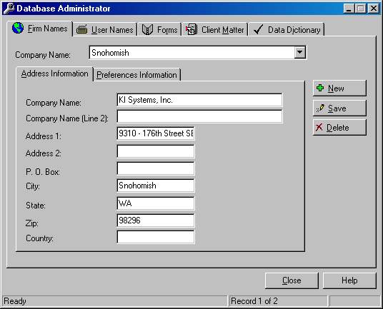
- Make any modifications regarding the firm information in the Address Information screen.
- Click the Preferences Information tab and the following screen appears:
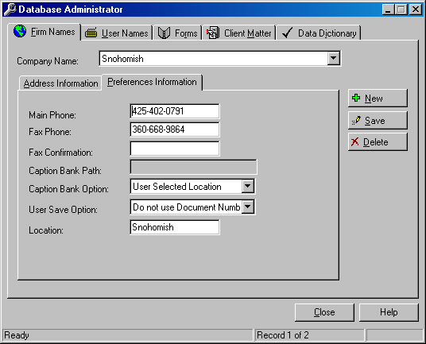
- Click Save when you are done.
- Click the User Names tab.
- Click on Address Book.
- Click on Find and you will see the names of the firm’s employees:

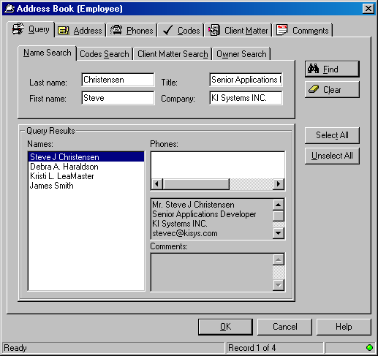
If there are any people listed here that are no longer with the firm, you can delete them:
- Click on the name in the Query Results screen.
- Click the Address tab.
- Click Delete button.
- Answer the prompt.
- Click Query tab and repeat if necessary.
Note: For complete instructions on how to use the KI Administrative Tool, refer to the Systems Administrator’s Guide.
To set each employees’ preferences:
- Click on the Query tab.
- Click Clear, then Find so all employee names are visible.
- Click on the first name in the list.
- Click OK.
- The screen will prefill with some information:
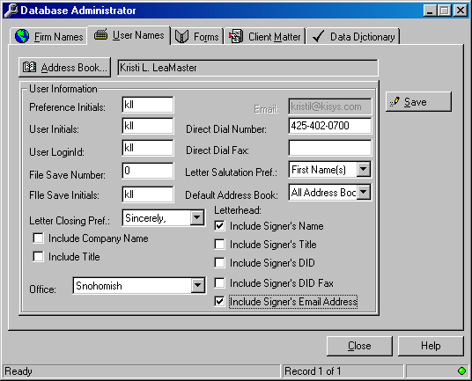
- If the user would like the firm name and/or title to always appear in the signature block, click in the appropriate box.
- If the person has a direct fax number, provide this information.
- Select the user’s preferences for letterhead and closing. If the preferred closing is not listed, you can add as many as you like in the Data Dictionary tab. Refer to the Systems’ Administrator’s Guide for details.
- Click Save.
- Repeat this process for all employees.

Step 7 – Accessing KI Systems Software from within Microsoft Word
- Open Microsoft Word and notice the KI Systems Toolbar located near the bottom of the application.
You can configure user controlled preferences for the templates and macros – or allow the users to modify the settings themselves. To modify user controlled preferences do the following:
- Click on the Macros button in the customized toolbar at the bottom of the screen.
- Click Settings and the following screen appears:
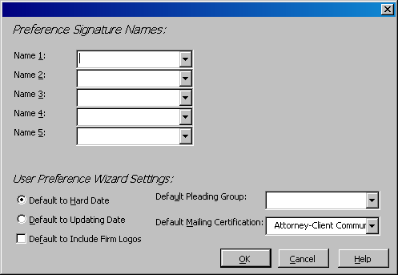
- If you have already chosen the five signature names, they will be filled in here. If not, do so now.
- Select the preferred date type for this user, and, if the user wants to include firm logos in all documents, click the box.
- Click on the Default Pleading Group menu and select a jurisdiction.
- Click on the Default Mailing Certifications menu and select one for this user.
- Click OK when you are done.
The workstation now has full preferences and access to the database. You may access templates and macros from the New Document Menu, Address Book features from the Address Book Menu and macros from the Macros menu.

