

MICROSOFT® WORD 2000

Systems Administrator Guide

9310 – 176 th Street S.E.
Snohomish, WA 98296-5028
Telephone: (425) 402-0791

KI Database Administrator 1
Topic Overview: 1
Features: 1
Firm Names Administration 2
Topic Overview: 2
User Names Administration 5
Topic Overview: 5
Client Matter Administrator 11
Topic Overview: 11
Data Dictionary 15
Topic Overview: 15
Data Dictionary: Letter Closing Preferences 16
Topic Overview: 16
Data Dictionary: Mailing Codes Administration 19
Topic Overview: 19
Data Dictionary: Phone Categories Administration 21
Topic Overview: 21
Data Dictionary: States Administration 23
Topic Overview: 23
Forms Administration 25
Topic Overview: 25
Workstation System Implementation Requirements 1
Required Desktop Applications and Drivers 1
Required Client Workstation Application Files 1
User Templates: 2
Workgroup Templates: 2
Pleading Templates 3
Workgroup Templates – Litigation Support: 4
Forms Files: 4
Startup-Path Files: 4
Windows Files: 5
KiForms.dll 5
Required Windows System Files: 5
KI Admin Logos: 5
Forms Organizer 1
Create a Standard Text Form 1
Create a Form with Fill-In Fields 3
Create a Form with Form Fields 7
Create a Macro Form 10
Logo Builder 1
Topic Overview: 1
Logo Builder 1
Modifying Stylized Logos: 2
MAPI Connector 1
Topic Overview: 1
Add KI Systems Address Book Service 1
To Access Addresses in Client Address Book Using Outlook 2
Remote Version 1
Topic Overview: 1
Create a Shortcut 1
Go Mobile 2
Go Network 3

KI Database Administrator

Topic Overview:
KI Database Administrator provides the System Administrator with tools to manage a number of settings and options used in the customization. Some information applies globally to everyone in the firm accessing the database. Other information applies to individuals, based on their preferences.
Note: In order to make changes to this database, you must be logged on as an administrator. If your firm’s Address Book is not SQL based, follow these steps:
- Click Start, Run and enter: kicfg
- Click OK
- Login ID and User Name should read: sa
- Click OK

Features:
Firm Names Administration. Information stored here is inserted into all signature blocks and in the title bar on dialog boxes. Location of the Caption Bank and the type of firm file save that will be used is also stored under Firm Names.

User Names Administration. Data stored here is accessed at various points during the document creation process. Information such as signature names, document numbering, DID number, and email address in letters and merge letters is stored here.

Client Matter Administration. Client Matter Numbers and descriptions are added or deleted here. Once entered into the system, client matter numbers are available to users to attach to database records for reference, searching, and mail merge functions.

Data Dictionary. Lists for closing preferences, mailing codes, logos, phone categories and states are managed here.

Forms Administration. Forms are added to or deleted from the Forms index using this tool.

Firm Names Administration

Topic Overview:
Firm Names Administration is a feature that stores Branch Office information for firms with single or multiple locations. Firm Names are managed through the Database Administrator.

To navigate around the Database Administrator, use the mouse, the tab and Enter keys or the assigned accelerator keys.

To Add or Edit Firm Names Entries
- Access the Database Administrator from the Start, Run Menu.
- Enter "kiadmin" in the text box and click OK.

The Firm Names tab is visible and the following screen appears:

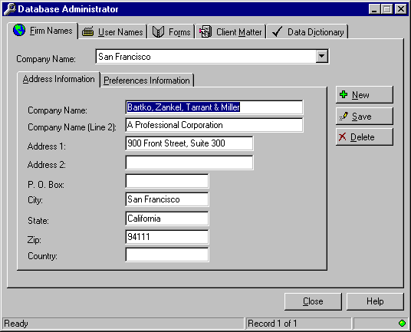

An entry must be made for every office in your firm.
- Complete the information on the Address Information tab.
Note: It is not necessary to type in the words "P.O. Box" in the PO box field.
- Continue on to the Preferences Information tab.

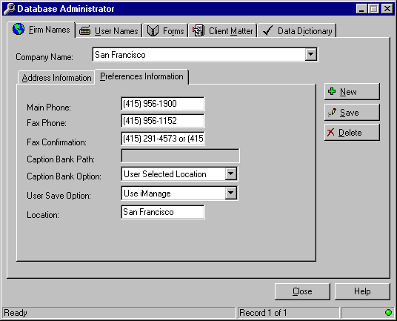

- Enter the Main Phone number of the current office.
- Enter the Fax Phone number.
- If you are using the Pleading Pak templates, enter the path where Caption Bank entries will be stored.

There are two Caption Bank Options:
User Selected Location option allows you to direct caption bank entries to any location you want.
Use Central Caption Bank option forces all caption bank entries to a location on the network for all users to share.
- Select the one best for your work environment.

There are three User Save Options:
Do not use Document Numbering will allow you to save documents use Word's default saving feature.
Use (Document Management System Name) is chosen if your firm has such a system.
Use Document Numbering allows you to save using KI System's File Save feature.
- Select the one best for your work environment.
- In the Location field, enter the name of the office or branch associated with the information provided on the Address Information and Preferences Information tabs.
- Press Alt+S or click on the Save button to save the record.

User Names Administration

Topic Overview:
User Names is a database feature that stores the following information for employees of the firm:
Preference Name
Preference Initials
User Initials
File Save Initials
File Save Number
Network Initials
Direct Dial Phone Number
Direct Dial Fax Number
Letter Salutation Preference
Default Address Book
Letter Closing Preference
Office Location
E-Mail Address
Bar Number

These preferences are managed using the Database Administrator. Modifications and additions made to this database should be performed by the System Administrator only because the data stored here affects a user's login capability and desktop preferences.

To navigate around the Database Administrator, use the mouse, the tab and Enter keys or the assigned accelerator keys.

Outlined below are instructions for editing, adding and deleting records.

To Edit User Names
- Access the Database Administrator from the Start, Run Menu.
- Enter "kiadmin" in the text box and click OK.
- Click on the User Names tab or press Alt+U.
- Click on the Address Book button to access the Employee Information stored in the database.
- Query the Address Book for the record you need to edit.
- Highlight the name in the Query Results screen.
- Click OK and the User Names tab appears filled in with the employee's information.

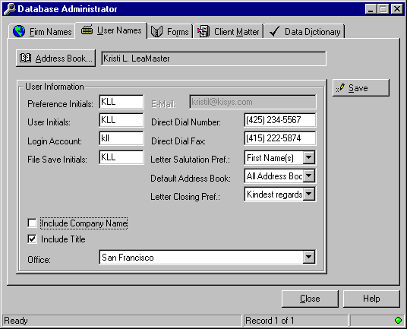

- Position the cursor in the field to be edited and make your changes.
- Click on Save when you are done.
- Click Close to exit the Database Administrator program.

To Add a User Name
- Access the Database Administrator from the Start, Run Menu.
- Enter "kiadmin" in the text box and click OK.
- Click on the User Names tab or press Alt+U.
- Click on the Address Book button.
- Click on the Address tab.
The following screen appears:

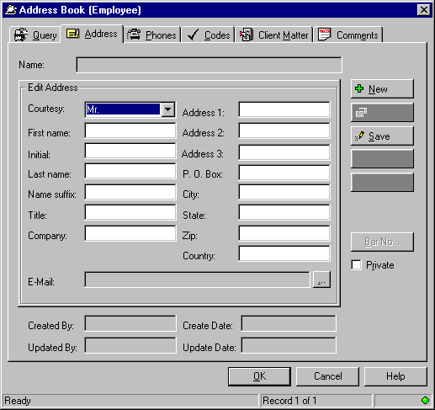

The screen should be void of information, except for the default Courtesy Title of "Mr." If this is not the case:
- Press Alt+N or click on the New button to clear your screen.
- Fill in the following fields: Courtesy, First name, Initial, Last Name and E-Mail.
- Press Alt+S or click on the Save button to save the record.

If the employee has a bar number:
- Click on the Bar Number button.
- The following screen appears:

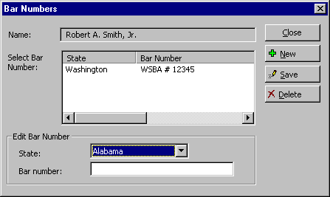

- Select a state from the State drop down list.
- Tab to the Bar number text box and enter the bar number.
- Click on Save.
- If more than one bar number needs to be entered, click on the New button and begin the process again.
- Click Close when you are done.
- Click OK.

Entering Data in the User Names tab:
- To enter new information for another new record, press Alt+N or click on the New button to clear your screen. Follow the procedure outlined above.
- Preference Name. Enter the user’s preferred name for signature blocks
- Preference Initials. Enter the user’s preferred initials for closings. Note: These do not necessarily need to correspond to the Preference Name.
- User Initials. Enter the user’s initials. This field allows insertion of an individual’s preferred signature name from the database.
- File Save Initials. File Save Initials can be letters, numbers or a combination of letters and numbers. Each individual’s File Save Initials must be unique. If your firm uses a Document Management System, this field can be left as is.
- File Save Number. The default is 0, so the first document saved will increment from 001. A combination of numbers and letters are used, allowing up to 46,555 unique document names per individual. If your firm uses a Document Management System, this field can be left as is.
- Network Initials. Enter the user’s network login name.
- Office. Select the appropriate office from the drop down list. Information for the branch Name, Address, Phones, Caption Bank (if applicable,) and Document Numbering selection is determined by the office indicated here. The branch locations are defined under Firm Names Administration.
- Direct Dial Number. Enter the user’s Direct Dial Number.
- Direct Dial Fax. Enter the user’s Direct Dial Fax Number.
- Letter Salutation Preference. Select from the drop-down list to set the user’s default Letter Salutation Preference, which can be changed while creating documents.
- Default Address Book. Select from the drop-down list to set the user’s default Address Book. The user will still have access to other address books, as applicable.
- When you are done entering data, click on Save.

To Delete User Names
- Access the Database Administrator from the Start, Run Menu.
- Enter "kiadmin" in the text box and click OK.
- Click on the User Names tab or press Alt+U.
- Click on the Address Book button.
- Query the database for the record you want to delete.
- Highlight the name in the Query Results area.
- Click on the Address tab.

The following screen appears:

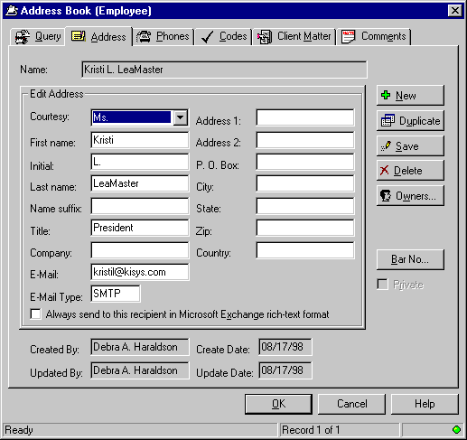

- Click on the Delete button.
- A confirmation window will appear. Click Yes or No as appropriate.
- Click OK then Close to exit the Database Administrator.

Client Matter Administrator

Topic Overview:
Client Matter is a database feature that stores information on Clients that is used primarily in Address Book queries. Client Matter Names and Numbers are managed through the Database Administrator. Client Matter information can be added, edited or deleted using this feature.

To navigate around the Database Administrator, use the mouse, the tab and Enter keys or the assigned accelerator keys.

To Add Client Matter Entries
- Access the Database Administrator from the Start, Run Menu.
- Enter "kiadmin" in the text box and click OK.
- Press Alt+M or click on the Client Matter tab.

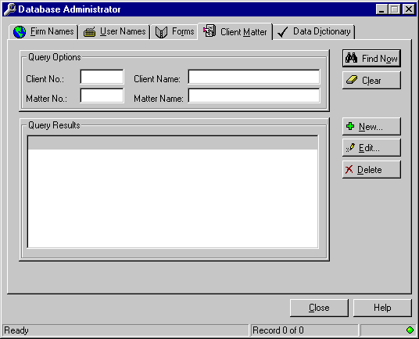

- Enter full or partial information in any of the Query Options fields. You can also use the wildcard character %.
- Click Find Now.
- If the matter does not exist, create it by clicking on the New button or pressing Alt+N.

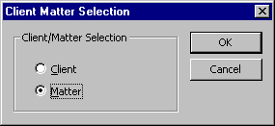

- If the Client exists in the database, select Matter and click OK to continue.
- If this is a new Client, select Client and supply the information on the New Record screen.
- Press OK to continue
Note: A Client Number must exist before you will be able to add a Matter Number. If you attempt to create a duplicate Client Number, you will receive a database error.

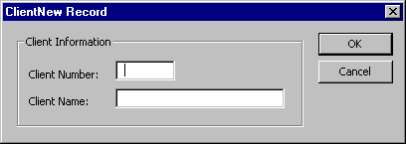

- If the Client Number already exists, select the New button from the Client Matter tab.
- From the Client Matter Selection options, select Matter and press OK.

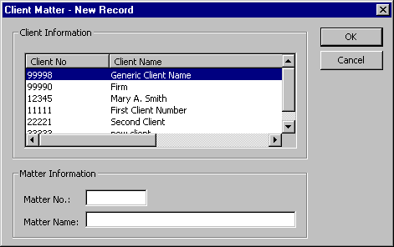

- From the Client Information drop down list, select the appropriate Client Number.
- Complete the information in the Matter No. and Matter Name boxes. Click on OK to continue.

To Edit Client Matter Information
- Access the Database Administrator from the Start, Run Menu.
- Enter "kiadmin" in the text box and click OK.
- Click on the Client Matter tab.
- Enter full or partial information in any of the Query Options fields. You can also use the wildcard character %.
- Click Find Now.

The following screen appears:

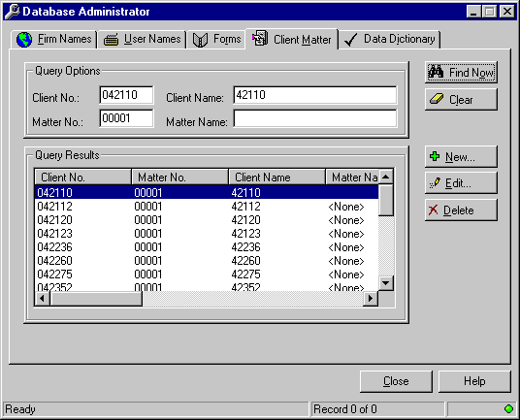

- From the Query Results area, highlight the client matter to be modified.
- Click on the Edit button or press Alt+E to continue.

To Delete Client Matter Entries
- Access the Database Administrator from the Start, Run Menu.
- Enter "kiadmin" in the text box and click OK.
- Click on the Client Matter tab.
- Enter full or partial information in any of the Query Options fields. You can also use the wildcard character %.
- Click Find Now.

The following screen appears:

- From the Query Results area, highlight the client matter to be deleted.
- Click on the Delete button or press Alt+D. You will be prompted to confirm deletion of the record.
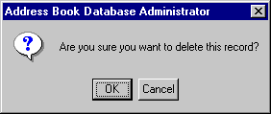

- Press OK or Cancel as appropriate.

Data Dictionary

Topic Overview:
Data Dictionary is a feature of Address Book, listing preferences for Letter Closings, Logo Label Type, Mailing Codes, Phone Categories and States.

To Access Data Dictionary:
- Access the KI Admin Tools from the Start, Run Menu.
- Enter "kiadmin" in the text box and click OK.
- Click on the Data Dictionary tab or press Alt+I.

The following screen appears:

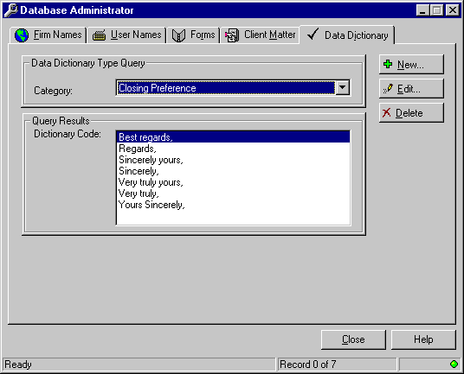

- Select the category you want from the drop down list.

Data Dictionary: Letter Closing Preferences

Topic Overview:
The Database Administrator allows you to edit, add and delete letter closings available to users in your firm using the Data Dictionary Administration feature.

Once the list has been modified to fit your needs, every individual in the firm can be assigned a default letter closing preference. Each user will still have the ability to select a different closing from the drop down list as part of the letter creation process.

To navigate around the Database Administrator, use the mouse, the tab and Enter keys or the assigned accelerator keys.

To Modify Letter Closing Preferences
- Access the KI Admin Tools from the Start, Run Menu.
- Enter "kiadmin" in the text box and click OK.
- Click on the Data Dictionary tab or press Alt+I.
- In the drop down list of categories, select Closing Preferences.

The following screen appears:

- To add a new closing, click the New button.
The following screen appears:

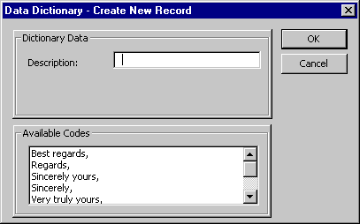

- Enter the new letter closing in the Description area, exactly as it should appear in a letter, including the comma.
- Press OK.
- To edit an existing closing, highlight the closing in the Query Results area and press Edit.
- Make the changes in the Description field.
- Press OK.
- To delete an existing closing, highlight the closing in the Query Results area and press Delete.

The following confirmation screen will appear:

- Press OK or Cancel as appropriate.
- When you are done with the Database Administrator, click on Close.

Data Dictionary: Mailing Codes Administration

Topic Overview:
The Database Administrator allows you to edit, add and delete mailing codes that are used for merge printing.

To navigate around the Database Administrator, use the mouse, the tab and Enter keys or the assigned accelerator keys.

To Modify Mailing Codes
- Access the KI Admin Tools from the Start, Run Menu.
- Enter "kiadmin" in the text box and click OK.
- Click on the Data Dictionary tab or press Alt+I.
- In the drop down list of categories, select Mailing Codes.

The following screen appears:

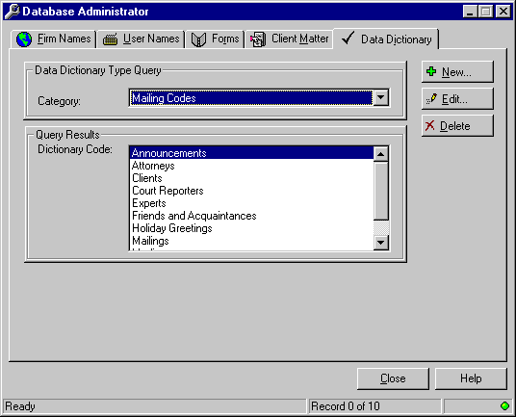

- To add a new mailing code, click the New button.
The following screen appears:

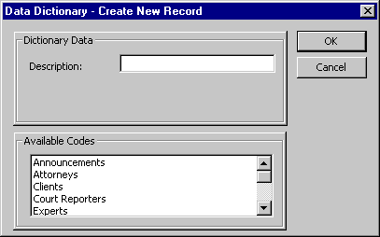

- Enter the new code in the Description area.
- Press OK.
- To edit an existing code, highlight the code in the Query Results area and press Edit.
- Make the changes in the Description field.
- Press OK.
- To delete an existing code, highlight the code in the Query Results area and press Delete.

The following confirmation screen will appear:

- Press OK or Cancel as appropriate.
- When you are done with the Database Administrator, click on Close.

Data Dictionary: Phone Categories Administration

Topic Overview:
The Database Administrator allows you to edit, add and delete phone categories that are available in the firm's Address Book.

To navigate around the Database Administrator, use the mouse, the tab and Enter keys or the assigned accelerator keys.

To Modify Phone Categories
- Access the KI Admin Tools from the Start, Run Menu.
- Enter "kiadmin" in the text box and click OK.
- Click on the Data Dictionary tab or press Alt+I.
- In the drop down list of categories, select Phone Categories.

The following screen appears:

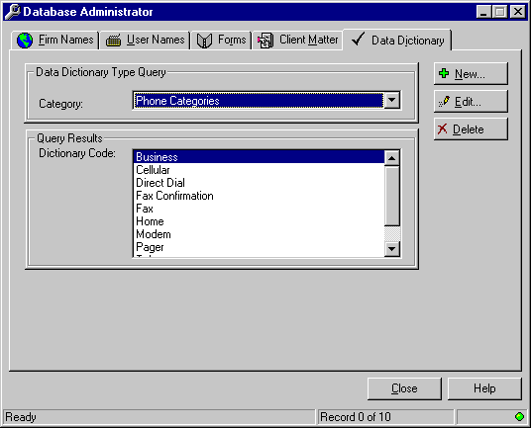

- To add a new phone category, click the New button.
The following screen appears:

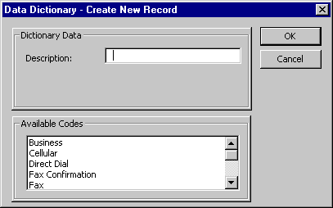

- Enter the new category in the Description area.
- Press OK.
- To edit an category, highlight the category in the Query Results area and press Edit.
- Make the changes in the Description field.
- Press OK.
- To delete an existing category, highlight the category in the Query Results area and press Delete.

The following confirmation screen will appear:

- Press OK or Cancel as appropriate.
- When you are done with the Database Administrator, click on Close.

Data Dictionary: States Administration

Topic Overview:
The Database Administrator allows you to edit, add and delete the names of states for bar number information. By default, the Address Book, as installed, has all fifty states listed in the States Category. This tool allows you to edit the list to include only those states in which attorneys are licensed.

To navigate around the Database Administrator, use the mouse, the tab and Enter keys or the assigned accelerator keys.

To Modify the List of States
- Access the KI Admin Tools from the Start, Run Menu.
- Enter "kiadmin" in the text box and click OK.
- Click on the Data Dictionary tab or press Alt+I.
- In the drop down list of categories, select States.

The following screen appears:

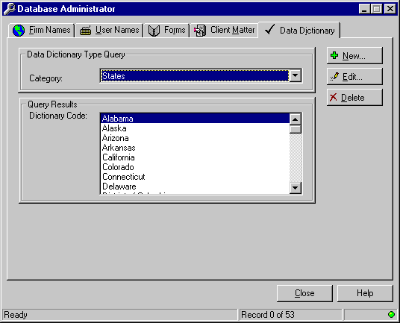

- To add a new state, click the New button.
The following screen appears:

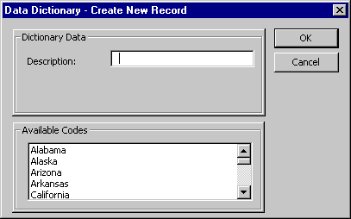

- Enter the new state in the Description area.
- Press OK.
- To edit an existing state name, highlight the state in the Query Results area and press Edit.
- Make the changes in the Description field.
- Press OK.
- To delete an existing state name, highlight the state in the Query Results area and press Delete.

The following confirmation screen will appear:

- Press OK or Cancel as appropriate.
- When you are done with the Database Administrator, click on Close.

Forms Administration

Topic Overview:
Forms Administration is a database feature that provides a means to add standardized forms to a central form bank for shared access by multiple users. Forms are managed through the Database Administrator.

To navigate around the Database Administrator, use the mouse, the tab and Enter keys or the assigned accelerator keys.

Outlined below are instructions for adding and editing Forms entries to the Form Bank.

To Add Forms Entries
- Access the Database Administrator from the Start, Run Menu.
- Enter "kiadmin" in the text box and click OK.
- Click on the Forms tab.

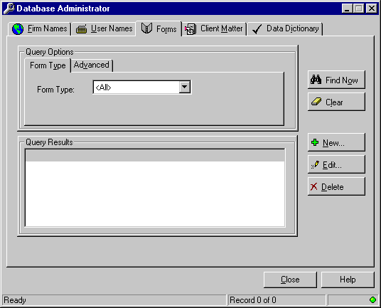

- Click on the New button.
- Complete the information on the Forms - Create New Record screen.

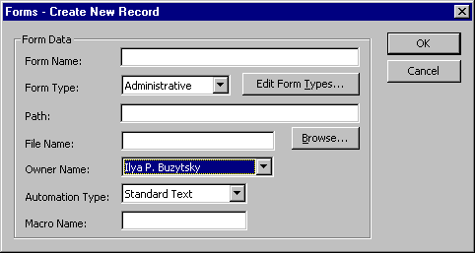

- Provide a name in the Form Name field. This is the name the user will see in the Query results screen when searching for a form.
- If the Form Type you want does not appear in the drop-down list, click on the Edit Form Types button.
- Click on the New button and provide a Description
- Click on Save then OK.
- Click on the Browse button to locate the form.
- Navigate to the location where the form resides and double click on the file name.
- The document name will appear in the File Name text box and the Path will be completed automatically.
- Select the Form Owner Name from the drop-down list.
- Select the appropriate option from the drop-down list: Standard Text, Word Fill-in Fields, Word Form Fields Standard and Macro.
Standard Text option represents insertion of straight text only, with no variables.
Word Fill-in Fields option prompts users to enter text in “pop up” text fields.
Word Form Fields option allows users to move from field to field entering text in the form (without prompts) until all fields are completed.
Macro option allows users to access forms created using VBA programming language, with option buttons, drop-down lists, and fill-in text boxes. If this option is selected, the name of the Macro must be included in the Macro Name box. Note: Macros must be stored in the KI Forms.dot template located in the Startup directory in order to function properly.
- If the form Automation Type is Macro, then provide the Macro Name.
- Press OK when done.

To Edit Forms Entries
Note: These are the instructions for editing the entries in the Form Bank, not for editing the actual forms. To edit forms, open the form in Word and begin editing.
- Access the Database Administrator from the Start, Run Menu.
- Enter "kiadmin" in the text box and click OK.
- Click on the Forms tab.

- Select a form type from the Form Type drop-down list, or use the default <All> to view all available forms.
- Click on the Find Now button.
- Click on the one you want.
- Click on the Edit button.
- Edit the fields as appropriate.
- Press OK then Close to exit the Database Administrator.

To Delete Forms Entries
- Access the Database Administrator from the Start, Run Menu.
- Enter "kiadmin" in the text box and click OK.
- Click on the Forms tab.

- Select a form type from the Form Type drop-down list, or use the default <All> to view all available forms.
- Click on the Find Now button.
- Click on the one you want.
- Click on the Delete button.

The following confirmation screen will appear:

- Press OK or Cancel as appropriate.
- When you are done with the Database Administrator, click on Close.

Workstation System Implementation Requirements
The setup program that installed the KI Systems Law Automation Tools put the files to run your customized software in the correct folders on your local drive. This section addresses where each file has been stored for reference.

Required Desktop Applications and Drivers

The following is a listing of the required Client Workstation Application and Driver requirements.

Applications:
Windows 98, 2000 or NT Workstation
Microsoft Office 2000

Drivers:
SQL Server drivers version 2.65.0213 or 3.60 or greater.

Required Client Workstation Application Files

The following is a listing of the required Client Workstation System files for the Customization and Client Address Book system. To illustrate local Word pathing, here is a screen shot from within Word 2000:

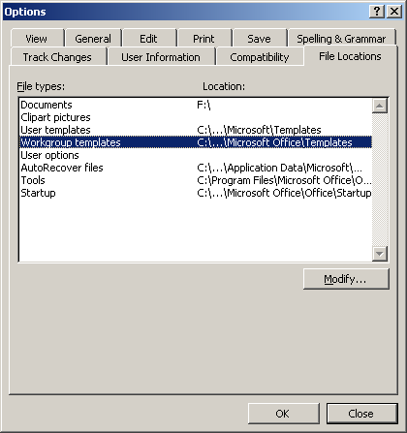

Please note that the User templates, Workgroup templates and Startup paths have been truncated. The three dots represent the folder Program files. For example, the complete path for startup would be: c:\program files\microsoft office\office\startup. You must follow these pathing rules to run the software successfully.

User Templates:
To be copied into the User-Template-Path (Local Drive Path Required)
File Name | Description
Normal.dot | Contains required structural components

Workgroup Templates:
To be copied into the Workgroup-Template-Path (Local Drive Path Required)
File Name | Description
KI - Envelope.dot | Com 10 Envelope template
KI - Fax.dot | Facsimile Cover Sheet template for multiple recipients
KI - Labels.dot | Avery Laser Labels - Product Number 5164 template
KI - Letter.dot | Letter template
KI - Memo.dot | Memorandum template
KI - Merge Envelope.dot | Mail Merge template (using Address Book merge codes) for Com 10 Envelopes
KI - Merge Envelope DS.dot | Mail Merge template (to a data source document) for Com 10 Envelopes
KI - Merge Labels 5164.dot | Mail Merge template (using Address Book merge codes) for Avery Laser Labels - Product Number 5164
KI - Merge Labels 5164 DS.dot | Mail Merge template (to a data source document) for Avery Laser Labels - Product Number 5164
KI - Merge Labels 5162.dot | Mail Merge template (using Address Book merge codes) for Avery Laser Labels - Product Number 5162
KI - Merge Labels 5162 DS.dot | Mail Merge template (to a data source document) for Avery Laser Labels - Product Number 5162
KI - Merge Letter.dot | Mail Merge template(using Address Book merge codes) for Letter
KI - Merge Letter DS.dot | Mail Merge template (to a data source document) for Letter
KI – Personal Envelope.dot | Personal envelope template.
KI – Personal Letter.dot | Personal letter template.
KI – Single Fax.dot | Fax Cover Sheet Template for single recipient

Pleading Templates
Workgroup-Template-Path (Local Drive Path Required)
WA Pleading Pak\KI – Generic Pleading.dot
WA Pleading Pak\KI - State Court of Appeals Brief.dot
WA Pleading Pak\KI - State Court of Appeals Pleading.dot
WA Pleading Pak\KI – PERC Pleading.dot
WA Pleading Pak\KI – Personnel Appeals Board Pleading.dot
WA Pleading Pak\KI - State Superior Court Pleading.dot
WA Pleading Pak\KI - State Supreme Court Brief.dot
WA Pleading Pak\KI – US Bankruptcy Court Pleading.dot
WA Pleading Pak\KI - US Court Appeals – 9th Circuit Brief.dot
WA Pleading Pak\KI - US Court Appeals – 9th Circuit Pleading.dot
WA Pleading Pak\KI - US District Court Pleading.dot
WA Pleading Pak\KI - US Supreme Court Brief.dot

Workgroup Templates – Litigation Support:
To be copied into the Workgroup-Template-Path (Local Drive Path Required)
Workgroup\Litigation Support\KI – Bates.dot | Bates labels template
Workgroup\Litigation Support\KI – Deposition Digest.dot | Deposition digest template
Workgroup\Litigation Support\KI – Exhibit.dot | Labels for exhibits template
Workgroup\Litigation Support\KI – Pleading Index.dot | Pleading index template
Workgroup\Litigation Support\KI – Recording Document.dot | Recording document template

Forms Files:
To be copied into a Network Directory where all users have full Read permissions.
(Note: Forms Administrator will need full Read/Write permissions.)
File Name | Description
KI Forms.dot | Forms template that stores macro code for shared network forms.  (Note: Forms created by your firm will be stored in the same Network Directory.)

Startup-Path Files:
To be copied into the Startup-Path (Local Drive Path Required)
File Name | Description
KI - Global Template.DOT | Global Add-in Template that provides foundation for Base System, Pleading Pak, Client Address Book, Document Numbering System and other global macros.

Windows Files:
File Name | Description
KIAB.dll | Custom DLL that provides the user front-end to the Client Address Book, System Logins, Signature Blocks, Bar Numbers and Print Address Book Report.
Kiabent.exe | Launches Address Book from the Desktop
KiAdmin.exe | Launches Admin Tool
Kicfg.exe | Launches configuration program for accessing Address Book
KiForms.dll | Custom DLL that provides user front-end for Forms
KiRes.dll | Custom Resource DLL
Kiword9.chm | On-line help file

Required Windows System Files:
File Name | Description
Kistore.dll | For retrieval of logo information
Abki3.dll | For retrieval of address book information
Abpki.inf | For retrieval of address book information
Mergeini.exe | For MAPI Connectivity
Mfc42.dll | For retrieval of address book information

KI Admin Logos:
To be copied into a Network drive determined by administrator
File Name | Description
Envelope Logo.doc | Logo for all Com 10 envelopes
Fax Logo.doc | Logo for fax and merge fax cover sheets
Label Logo.doc | Logo for all Avery 5164 labels
Letter Logo.doc | Logo for all letters
Memo Logo.doc | Logo for memorandum
Personal Envelope.doc | Logo for personal monarch envelope
Personal Letter.doc | Logo for personal letter
Pleading Logo.doc | Logo for all pleadings

Forms Organizer
Topic Overview:
The Forms Organizer provides a user friendly interface that allows immediate access to form or brief bank information from Microsoft Word. It combines the efficiency of a database search engine with the automation and rich text capabilities of Microsoft Word. The Forms Organizer gives you the flexibility to create, manage and automate your firm’s document creation processes using forms or a brief bank.

Forms can consist of:
- Standard Text.
- Automated Text via Word Merge Fields.
- Custom Forms automated via Word Basic macros or Word Visual Basic for Applications macros.

Forms Organizer features include Quick Search, Advanced Search, categorization of forms by type, descriptive name or author.

Create a Standard Text Form
- Type the text of your form in Word, formatting the text as it will appear in the document.
- If the form is going to be inserted into the current document, save it as a Word DOC (document.) If the form is going to be launched as a new document, save it as a Word DOT (template.)
- Move the form to the shared network forms directory. Create the index entry in the KI Admin Tool.

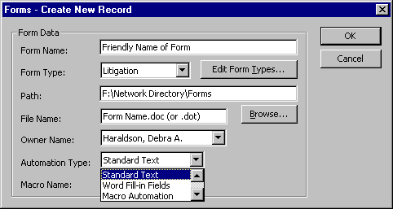

Select Standard Text as the Automation Type for Fill-In field forms.

Create a Form with Fill-In Fields
- Type the text of your form in Word, leaving a * (asterisk) at each location where user will be providing Fill-In information.
- Create a Fill-In field at each * location as follows:
- Delete the *.
- Click on Insert Field. In the Field dialog box select Mail Merge on the left under Categories. Select Fill-in on the right under Field names.
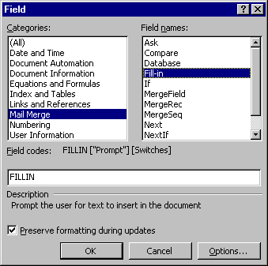
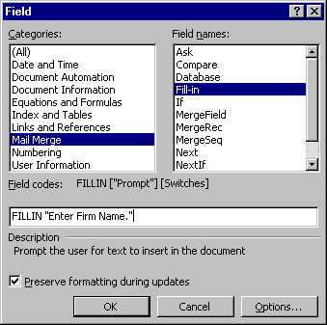
Next to the word FILLIN in the text box, type the text of the prompt you would like the user to see. Enclose the text in quotes, as the example indicates below.

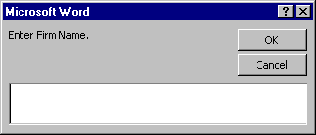
When you click on OK, a sample of the Fill-in will show on the screen.

DO NOT ENTER INFORMATION IN THE SAMPLE FILL-IN BOX. Click on OK to continue.
- To edit Fill-in prompts, turn field codes on. (Tools, Options, View, Field codes.) Click on the check box next to Field codes to turn codes on.
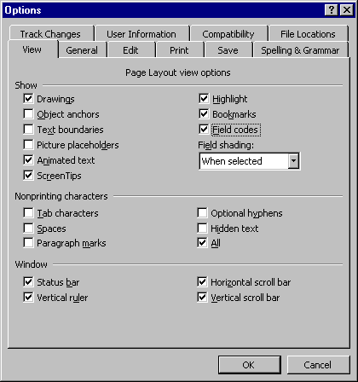
For each Fill-In field, you should see text in the following format:
{FILLIN “Enter Firm Name.” \* MERGEFORMAT}
The text enclosed in quotes represents the prompt users will see when running the form. You may edit the text by simply typing in your changes.

You may format the field as you would any word text. Select the entire field, then apply formatting (e.g., ALL CAPS, Bold, Underline.) The text typed in by users will be formatted accordingly in the completed document.

- If the form is going to be inserted into the current document, save it as a Word DOC (document.) If the form is going to be launched as a new document, save it as a Word DOT (template.)

- Move the form to the shared network forms directory. Create the index entry in the KI Admin Tool.

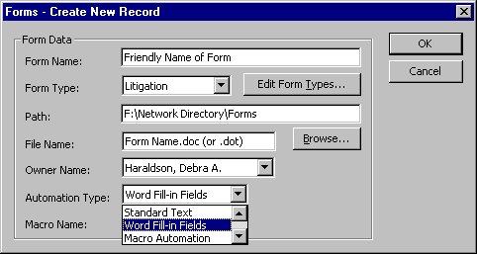

Select Word Fill-in Fields as the Automation Type.

Create a Form with Form Fields
- Type the text of your form in Word, leaving a * (asterisk) at each location where Form Field will be inserted.
- 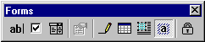Click on View Toolbars Forms to view the Forms toolbar.

- Create a Form field at each * location as follows:
- Delete the *.
Text Form Fields: Click on the “ab” button on the Forms toolbar. Double-click on the field to get the Properties Box. Complete the options in the dialog that appears on the screen

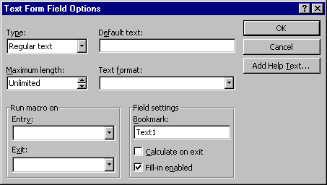

Check Box Form Fields: Click on the checkmark button on the Forms toolbar. Double-click on the field to get the Properties Box. Complete the options in the dialog that appears on the screen.
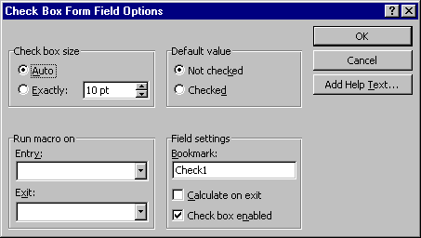

Drop-Down Form Fields: Click on the drop-down button on the Forms toolbar. Double-click on the field to get the Properties Box. Complete the options in the dialog that appears on the screen.
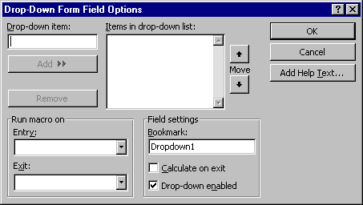

4. If the form is going to be inserted into the current document, save it as a Word DOC (document.) If the form is going to be launched as a new document, save it as a Word DOT (template.)

- Move the form to the shared network forms directory. Create the index entry in the KI Admin Tool.

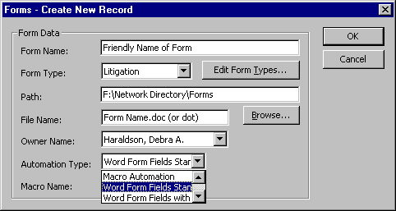

Select Word Form Fields Standard as the Automation Type for Form Field forms.

Note: When you use this form, you must tab past the very last form field, whether filled in or not, to unprotect the form for future editing.

Create a Macro Form
- Type the text of your form in Word, formatting the text as it will appear in the document.
- Word 97’s programming language is Visual Basic for Applications. Development of forms using Macro Automation will require an advanced understanding of Word and at least some understanding of macro programming in Word Basic (Word 7.0 programming language) or Visual Basic for Applications. Macro Automation can be achieved through Macro Record commands, however creating dialog boxes to receive user input and insert into forms can be challenging for novice programmers.
- If the form is going to be inserted into the current document, save it as a Word DOC (document.) If the form is going to be launched as a new document, save it as a Word DOT (template.)
- Move the form to the shared network forms directory. Create the index entry in the KI Admin Tool.
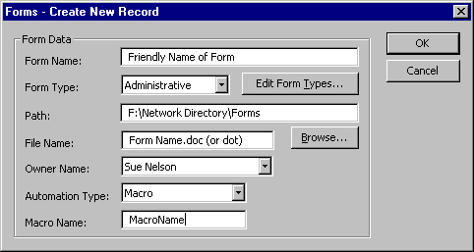
Select Macro as the Automation Type for Macro forms. Enter the name of the macro that will execute your code in the Macro Name box.

Logo Builder

Topic Overview:
Often company information will change. Whether it is a new address, new firm name, new zip code, new area code, different fax number, etc. We are often asked if KI Systems must modify the templates if this occurs. The answer most often is – no. KI Systems’ Office 2000 Business Pak includes several Logo Builder documents. These documents allow you to:

- Create/Modify the stylized firm logos used in Business Pak templates
- Stylized logos can include formatted text and/or graphics
- The Stylized logos are stored within the Address Book database and are retrieved by the templates and inserted into new documents.
- Because stylized logos are stored in the database, no desktop modification of Autotext entries or desktop templates are needed to update this information.

Logo Builder
The Business Pak includes the following stylized logo documents:

- Letter Logo
- Personal Letterhead Logo
- Memo Logo
- Fax Logo
- Envelope Logo
- Label Logo
- Personal Envelope Logo
- Pleading Logo

Your customized version may include additional Logo Builder documents. At installation time, the Logo Builder documents will contain your firm’s settings, fonting, layout and graphics requested in the Business Pak Workbook.

Logo Builder documents should not be distributed to user Workstations. Only administrators or those individuals assigned the task of maintaining office logo information should have access to these files.

Warning: When information in the Logo Builder documents are modified and saved – this will globally take affect on all users’ workstations. Please ensure that any modifications you make are correct before saving changes in the Logo Builder documents.

Modifying Stylized Logos:
The following steps outline the process to change and/or modify company information and logo formatting for the Business Pak templates:

- Load the KI Admin Tool
- From the Company Tab, modify the existing site entry as desired and press Save
- Open MS Word 2000
- Open the desired Logo Builder document.
- The Logo Builder process will prompt you to select the Office Location for which you wish to make modifications.

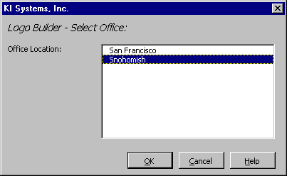

Note: The Office Location list may have one or many sites, depending on your firm.

- The Logo Builder document opens with the current Logo Layout for the template type (i.e. Letter).
- If changes have been made to the Company Information contained in the KI Admin Tool – OR – if your logo contains additional text not stored in Company Information (i.e. “Telephone: ” or “Facsimile: ”before office phone numbers) – OR – if your logo contains graphic file(s). You will see the following prompt:

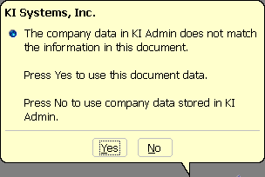

- If the modifications are minor and you wish to retain most the the current stylized logo format, click “YES”
- If your stylized logo contains a graphic, click “YES”

- If you would like to start from scratch (with only the information from the Company Information tab, click “NO”

- With the stylized logo on the screen, make the desired modifications. Warning: Your Logo Builder documents have been sized to match the available space in the corresponding Business Pak template(s). Do not change the page setup/size of the Logo Builder document. Do not allow your changes to extend to more than one page.

- You may modify text, font and paragraph attributes. We recommend that your use direct character formatting – rather than styles in Logo Builder documents.

- Review your modifications and click on “Set Logo Modifications”

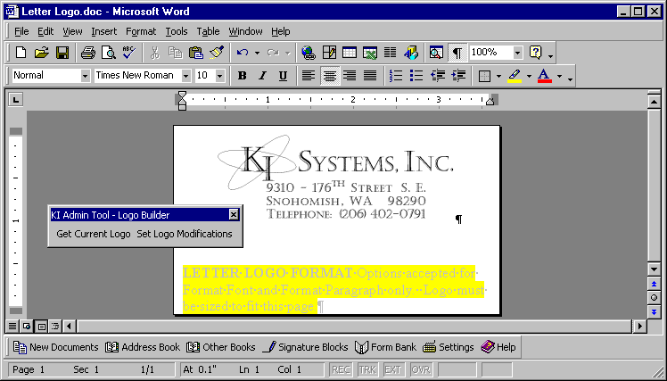

- To verify changes have been saved to the database, press Ctrl+A to select all text in the Logo Builder document and press Delete.

- Click on the “Get Current Logo” button and the stylized logo information will reappear in the Logo Builder document.

- Verify that all information is correct then save the final changes to the Logo Builder document.

All desktops will now use the updated Logo information. Repeat the above steps for each Logo Builder document type.

Note: Firms may need KI Systems assistance to modify template layout attributes if the look of the firm’s logo has significantly changed.

MAPI Connector
Note: The firm did not purchase the MAPI Connector. However, it is a component you may select to purchase later. If so, this section covers the administration of this product.

Topic Overview:
Address Book MAPI version provides access to your Address Book data from applications such as Microsoft Outlook, Exchange and Schedule+.

Add KI Systems Address Book Service
You will need to add the KI Systems Address Book service your existing Outlook profile.

Close Microsoft Word and Outlook.
Click Start, Settings, Control Panel, Mail.
A screen similar to this one appears:

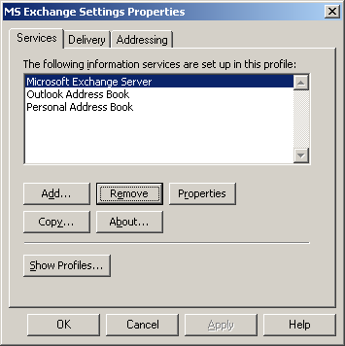

Click Add.
A screen similar to this one appears, displaying the available services:

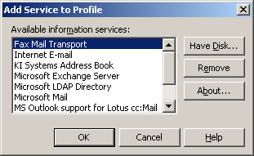

Click the service called “KI Systems Address Book” and click OK.
A screen similar to this one appears, displaying the services that are assigned to the profile:

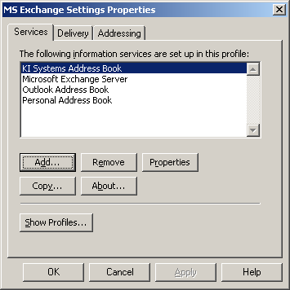

Click OK.

To Access Addresses in Client Address Book Using Outlook
Launch Outlook.
To gain access to the emails in the Client Address Book, click on the Address Book button in the toolbar or click Tools, Address Book.
The default Address Book will appear.
Click the “Show names from the” drop-down box and select “Firm email contacts.”

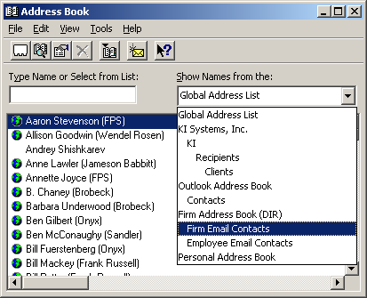

Note: Only records containing email addresses will appear in the list.

To add an email address to a record in the Client Address Book, search for the record, click the Address tab then the Email button.

Remote Version

Topic Overview:
Take your office on the road! KI Systems Address Book – Remote Version give users away from the office the same features that are available to network users. This includes the ability to:

- Access the firm’s Address Book contact information while “On the Road.”
- Create Documents using the same process use in the Office.
- Track creation of new Address Records and modifications to existing records while “On the Road.”
- Synchronize the “On the Road” Address Book modifications with the network database.

Create a Shortcut
To access the Remote Version easily, create a short cut to the program cabsync.exe:
Right mouse click anywhere on a blank area of the desktop
Select New, Shortcut
Click the Browse button
Navigate to: c:\program files\ki systems\cabsync.exe
With cabsync.exe highlighted, click OK
Click Finish

Go Mobile
To download the records that you own from the Client Address Book to your Remote Version of the database, double click on the Cabsync.exe shortcut icon. The following screen will appear:
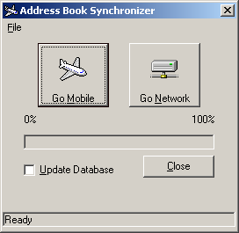

Click the Update Database check box
Click Go Mobile
In the message bar at the bottom, you will see the message “Mobile Database Updated.”
Click Close

Go Network
While working in remote mode, you can add, modify and delete client records from your database. When you are back in the office and want to upload your records to the Client Address Book on the firm’s network:

Double click on the Cabsync.exe shortcut icon. The following screen will appear:

Click the Update Database check box
Click Go Network
In the message bar at the bottom, you will see the message “Network Database Updated.”
Click Close

Microsoft Word 2000 Customization  Hot-Key Card |  | Microsoft Word 2000 Customization  Hot-Key Card
Customization Customization  Ctrl + Alt + A Address Book Ctrl + Alt + D New Document Menu  Ctrl +S File Save Ctrl + Shft + R Get Address Book Entry  Ctrl + Alt + S Signature Blocks Ctrl + Shft + X Caption Finish  Ctrl + Shft + G Form Bank  Formatting  Ctrl + 1 Single Space  Ctrl + 2 Double Space |  | Customization Customization  Ctrl + Alt + A Address Book Ctrl + Alt + D New Document Menu  Ctrl +S File Save Ctrl + Shft + R Get Address Book Entry  Ctrl + Alt + S Signature Blocks Ctrl + Shft + X Caption Finish  Ctrl + Shft + G Form Bank  Formatting  Ctrl + 1 Single Space  Ctrl + 2 Double Space

Microsoft Word 2000 Customization  Hot-Key Card |  | Microsoft Word 2000 Customization  Hot-Key Card
Customization Customization  Ctrl + Alt + A Address Book Ctrl + Alt + D New Document Menu  Ctrl +S File Save Ctrl + Shft + R Get Address Book Entry  Ctrl + Alt + S Signature Blocks Ctrl + Shft + X Caption Finish  Ctrl + Shft + G Form Bank  Formatting  Ctrl + 1 Single Space  Ctrl + 2 Double Space |  | Customization Customization  Ctrl + Alt + A Address Book Ctrl + Alt + D New Document Menu  Ctrl +S File Save Ctrl + Shft + R Get Address Book Entry  Ctrl + Alt + S Signature Blocks Ctrl + Shft + X Caption Finish  Ctrl + Shft + G Form Bank  Formatting  Ctrl + 1 Single Space  Ctrl + 2 Double Space

