

MICROSOFT® WORD 2000

Forms Bank Organizer

9310 – 176 th Street S.E.
Snohomish, WA 98296-5028
Telephone: (425) 402-0791

Table of contents

Forms Bank Organizer 2
Overview 2
KI Admin Tool 2
Form Types 3
Create a Standard Text Form 4
Create a Form with Fill-In Fields 5
Create a Form with Form Fields 9
Create a Macro Form 13

Forms Bank Organizer

Overview
KI Systems’ Forms Bank Organizer is an add-on package for Microsoft Word. The Forms Bank Organizer provides a user friendly interface that allows immediate access to form or brief bank information from Microsoft Word. The Form Bank Organizer combines the efficiency of a database search engine with the automation and rich text capabilities of Microsoft Word.

The Forms Bank Organizer allows forms to consist of standard text, automated text via Word merge fields or custom forms automated via Word Visual Basic® for Applications macros. The Forms Bank Organizer gives you the flexibility to create, manage and automate your firm’s forms or brief bank processes.

Features include Quick Search, Advanced Search, categorization of forms by type, descriptive name or author. The Forms Pak includes an administration tool that makes forms management, updates and distribution a simple process.

Once you have installed this product, you can begin designing forms for firm-wide use. If you would rather have KI Systems create your forms for you, complete the appropriate forms located at the back of this workbook and return them to us.

KI Admin Tool
The KI Admin Tool is a comprehensive database management tool that allows your system administrator to easily modify Office Location, User Preference Settings, Forms Bank Organizer entries and database settings.

Form Types
A standard text form is one with no prompts of any kind. It just contains text that, once called up from the Form Bank, will be inserted where the cursor is in the current document. A form with merge codes contains prompts that will stop on the screen and wait for the user to provide the information. The contents in this form will be inserted where the cursor is in the current document.

Another type of merge code document is one created with Form Fields. This type of form would be appropriate if the information requested requires more than just text, for example, a check box or a drop down menu from which to select certain information.

A more complicated form is one created using macros. This type of form is preferred if access to the firm’s address book is a requirement for completion of the form. Because a macro form can have more complicated user input screens, this type of form is much more versatile if the user needs to go back and forth between input screens. None of the other forms offer this flexibility.

Create a Standard Text Form

- Type the text of your form in Word, formatting the text as it will appear in the document.
- If the form is going to be inserted into the current document, save it as a Word DOC (document.) If the form is going to be launched as a new document, save it as a Word DOT (template.)
- Move the form to the shared network forms directory. Create the index entry in the KI Admin Tool.

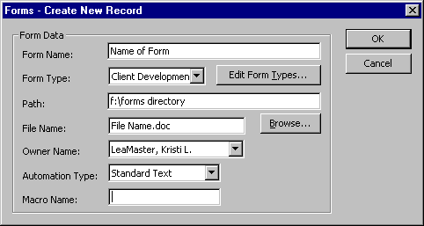

Select Standard Text as the Automation Type.

Create a Form with Fill-In Fields

- Type the text of your form in Word, leaving a * (asterisk) at each location where user will be providing Fill-In information.
- Create a Fill-In field at each * location as follows:
- Delete the *.
- Click on Insert Field. In the Field dialog box select Mail Merge on the left under Categories. Select Fill-in on the right under Field names.
- Next to the word FILLIN in the text box, type the text of the prompt you would like the user to see. Enclose the text in quotes, as in the example below:

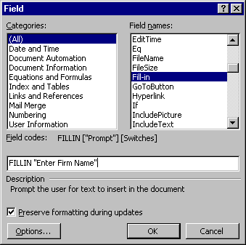

When you click on OK, a sample of the Fill-in will show on the screen:

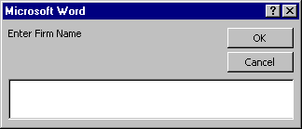

DO NOT ENTER INFORMATION IN THE SAMPLE FILL-IN BOX. Click on OK to continue.
- To edit Fill-in prompts, turn field codes on. (Tools, Options, View, Field codes.) Click on the check box next to Field codes to turn codes on.

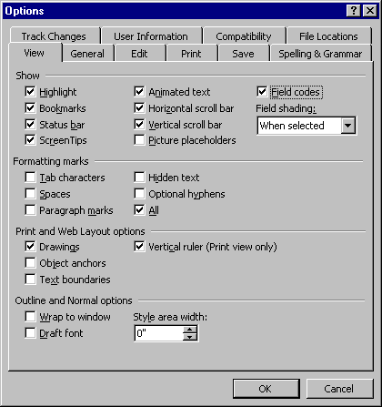

For each Fill-In field, you should see text in the following format:
{FILLIN “Enter Firm Name.” \* MERGEFORMAT}
The text enclosed in quotes represents the prompt users will see when running the form. You may edit the text by simply typing in your changes.

You may format the field as you would any word text. Select the entire field, then apply formatting (e.g., ALL CAPS, Bold, Underline.) The text typed in by users will be formatted accordingly in the completed document.

- If the form is going to be inserted into the current document, save it as a Word DOC (document.) If the form is going to be launched as a new document, save it as a Word DOT (template.)

- Move the form to the shared network forms directory. Create the index entry in the KI Admin Tool.

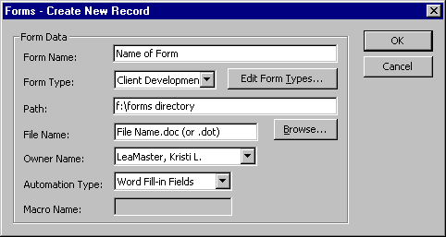

Select Word Fill-in Fields as the Automation Type.

Create a Form with Form Fields

1. Type the text of your form in Word, leaving an * (asterisk) at each location where Form Field will be inserted.
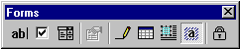2. Click on View Toolbars Forms to view the Forms toolbar.

3. Create a Form field at each * location as follows:
- Delete the *.

Text Form Fields: Click on the “ab” button on the Forms toolbar. Double-click on the field to get the Properties Box. Complete the options in the dialog that appears on the screen.

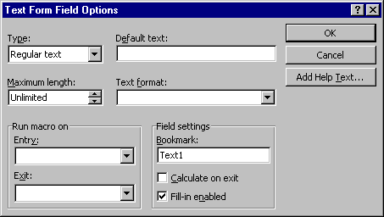

Check Box Form Fields: Click on the checkmark button on the Forms toolbar. Double-click on the field to get the Properties Box. Complete the options in the dialog that appears on the screen.

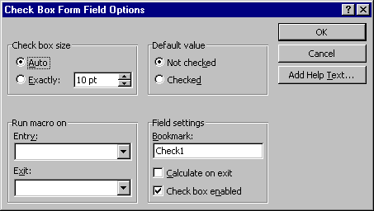

Drop-Down Form Fields: Click on the drop-down button on the Forms toolbar. Double-click on the field to get the Properties Box. Complete the options in the dialog that appears on the screen.

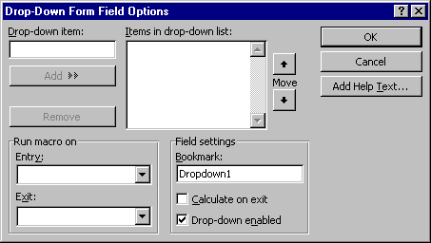

4. If the form is going to be inserted into the current document, save it as a Word DOC (document.) If the form is going to be launched as a new document, save it as a Word DOT (template.)
- Move the form to the shared network forms directory. Create the index entry in the KI Admin Tool.

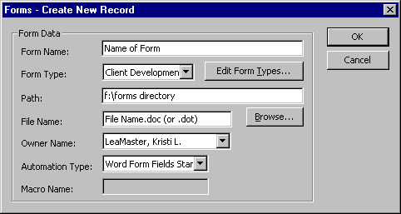

Select Word Form Fields Standard as the Automation Type.

Note: When you use this form, you must tab past the very last form field, whether filled in or not, to unprotect the form for future editing.

Create a Macro Form

- Type the text of your form in Word, formatting the text as it will appear in the document.
- Word’s programming language is Visual Basic for Applications (VBA). Development of forms using Macro Automation will require an advanced understanding of Word and VBA. Macro Automation can be achieved through Macro Record commands, however creating dialog boxes to receive user input and insert into forms can be challenging for novice programmers.
- Save the form as a Word DOT (template) file.
- Move the form to the shared network forms directory. Create the index entry in the KI Admin Tool.

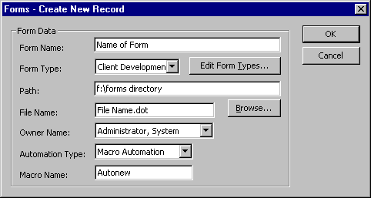

Select Macro as the Automation Type and Autonew as the Macro Name.

MERGE FIELD CODES FORM REQUEST

NEW FORM NAME: _________________________________________________

Complete information must be submitted in order to process your request to include a new automated form in the firm's customization. If you have questions concerning any of the items on this request, please call KI Systems for assistance.

Printout of Sample Text and Formatting. Please attach a sample with this request form. The sample should look exactly the way the final text should be formatted. Note: Indicate location of fill-in fields and corresponding text, if applicable.

Department or Office Approval of Form as Standard. Forms that will be included in the firm's customization need approval from one of the following sources: Department Chair, Office Administrator, MIS or Focus Group. Please have a representative indicate approval.

User Entry to be Inserted in Form.
Location/Bookmark Name | Fill-In Text/User Prompt
(e.g., Addressee) | (e.g., Enter Addressee’s Full Name: )

Additional Formatting Instructions, not covered above. Use reverse side or attach a separate sheet of paper if necessary.

Note: Change requests submitted following commencement of application development are subject to additional charges.
FORM AUTOMATION REQUEST

NEW FORM NAME: _________________________________________________

Complete information must be submitted in order to process your request to include a new automated form in the firm's customization. If you have questions concerning any of the items on this request, please call KI Systems for assistance.

Printout of Sample Text and Formatting. Please attach a sample with this request form. The sample should look exactly the way the final text should be formatted. Note: Indicate location of fill-in fields and corresponding text, if applicable.

Department or Office Approval of Form as Standard. Forms that will be included in the firm's customization need approval from one of the following sources: Department Chair, Office Administrator, MIS or Focus Group. Please have a representative indicate approval.

User Entry to be Inserted in Form.
Location/Bookmark Name | Dialog Box Instruction/User Prompt
(e.g., Addressee) | (e.g., Enter Addressee’s Full Name: )

Additional Formatting Instructions, not covered above. Use reverse side or attach a separate sheet of paper if necessary.

Note: Change requests submitted following commencement of application development are subject to additional charges.
TEXT ONLY FORM REQUEST

LIST ALL TEXT ONLY NEW FORM NAMES BELOW.

Complete information must be submitted in order to process your request to include a new automated form in the firm's customization. If you have questions concerning any of the items on this request, please call KI Systems for assistance.

Printout of Sample Text and Formatting. Please attach a sample with this request form. The sample should look exactly the way the final text should be formatted.

Department or Office Approval of Form as Standard. Forms that will be included in the firm's customization need approval from one of the following sources: Department Chair, Office Administrator, MIS or Focus Group. Please have a representative indicate approval.

Names and File Locations of Text Only Forms.
Form Name | File Location
(e.g., Notice of Appearance) | (e.g., F:\Forms\NOA.doc)

Additional Formatting Instructions, not covered above. Use reverse side or attach a separate sheet of paper if necessary.

Note: Change requests submitted following commencement of application development are subject to additional charges.

