Footer Macro – Installation Guide
This CD contains your customized version of KI Systems’ Footer Macro software.
This software is compatible with Microsoft Word 2002 and iManage DeskSite 6.0.1a HotFix 10a.
This software does not include compatibility for any other iManage product versions.
Prior to installing this product, please verify the presence and functionality of Word 2002 and DeskSite 6.0.1a HotFix 10a within your environment.
During the installation process, files will be copied to and registered with the local workstation. These files provide the functionality of the Footer Macro.
KI Systems provides a wide range of enterprise software and services meeting the needs of Corporate and Legal.

Call us today at 425-402-0791
or visit our website at:
www.kisys.com
Table of Contents
Client Installation 2
To Install the Footer Macro Software 2
How to Use the Footer Macro 6
Automatic Footer Updates 6
How the Footer Macro Displays Information 6
How To Place the DMS Footer at the End of the Document 7
How To Place the DMS Footer in the Document's Footer 8
Hummingbird 5.0 DMExtension\Integrated Application Features 9
To Un-Install the Footer Macro Software 10

Client Installation

To Install the Footer Macro Software
- Please close all Microsoft Office XP applications prior to the installation of the Footer Macro.
- Insert the CD in the CD drive.
- The install program should launch automatically. If it does not, use My Computer or Windows NT Explorer to access the KIFOOTER.EXE setup file.
- If you have received the setup program as an attachment to email – save the attachments to your local workstation or network drive. Navigate to and run KIFOOTER.EXE from your selected location. The install program will launch and the following dialog will appear:
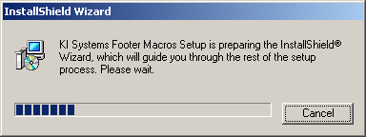

- Following InstallShield initialization, the following dialog will appear:
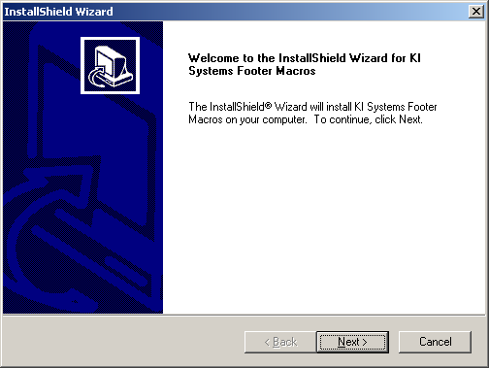
- Click Next to begin the Footer Macro installation. The following dialog will appear:
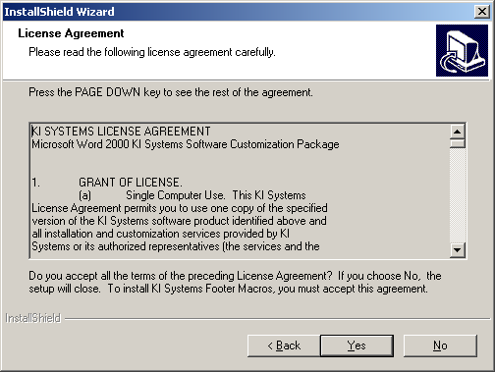

- Review the terms and conditions of the License Agreement and click Yes to accept and continue. The following dialog will appear:
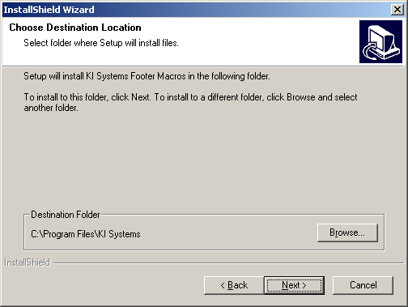

- You may select the default installation location or Browse to choose an alternate location. Please note: If you have other KI Systems software products installed on this workstation, this dialog will not appear and the additional Footer Macro components will be installed into the existing location for our software products.
- The Footer Macro installation process will begin.
- If the installation detects Microsoft Office XP components are running on the workstation, the following dialog box will appear:
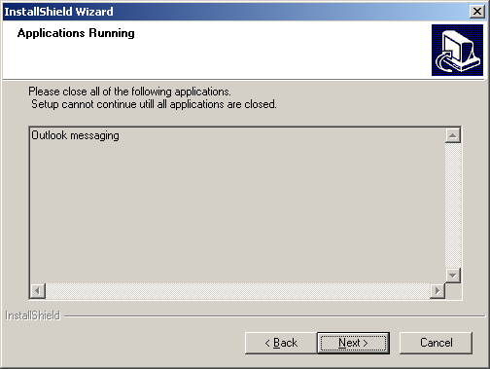

- Please close any listed applications and press Next to continue the installation.
- The following dialog will appear:
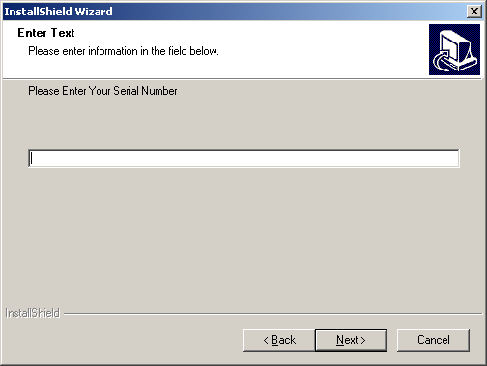

- Your product Serial Number can be found on the CD or as an attachment to the email that accompanied your software installation program. The serial number is found in the file named Notes.txt. If you have received a 30-Day Demo version the software will expire on the 31st day following installation. Locate and enter the serial number provided.
- The software installation will proceed and will automatically end upon completion. There is no need to re-boot your workstation following the installation of the Footer Macro software.
- When the installation has completed, launch Word 2002,
- At the bottom of Word’s screen, you will see a new toolbar.

How to Use the Footer Macro

Automatic Footer Updates
The Footer Macro automatically detects if the "Doc No." field code resides within a Word document. If it exists, the display information will be updated automatically each time the document is Opened, Saved, Saved As a New Version, and if the profile card is edited. The Footer Macro's use of application events makes this possible.

How the Footer Macro Displays Information
KI Systems Footer Macro utilizes a Word Custom Document Property Field Code (named "Doc No.") to display and automatically update footer information from the document management system. The field code is wrapped with a Word Bookmark called "FileNum." This field code and corresponding bookmark can be placed anywhere in a document (i.e. footer, end of text, certain sections, etc.). It can also be placed in the underlying template so that it is automatically available as new documents are created. Our Footer Macro also provides a Custom Toolbar and Macro called "Insert Doc No." that enables the user to quickly insert the custom field code into customer or legacy documents that do not currently have the field code.
In your document, with View Field Codes turned on, the field code displays as follows:
{ DOCPROPERTY "DOC NO." \* MERGEFORMAT }
In your document, with View Field Codes turned off and if your document has been saved to the DMS, the footer will display similar to the following:
99999-00001\12345.1

How To Place the DMS Footer at the End of the Document
- Place your cursor at the end of the document.
- Click the Insert Doc No. Button on the toolbar.
- The field code will take on the Style that existed at the cursor location. If desired, you may format the field code font, size or other attributes.
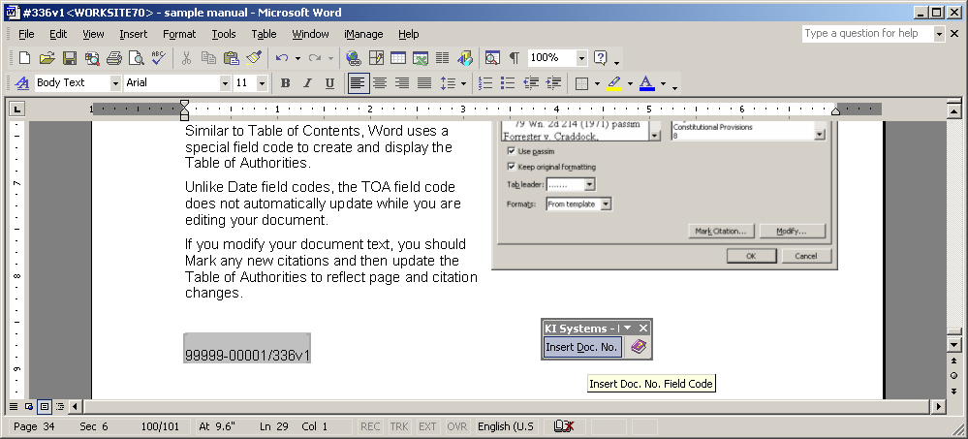

How To Place the DMS Footer in the Document's Footer
- If the document's footer already contains text or page number information you can create a new line or position the cursor at the desired location amongst the existing text.
- Click on the Insert Doc No. button and the field code will be inserted.
- The field code will take on the Style that existed at the cursor location. If desired, you may format the field code font, size or other attributes.
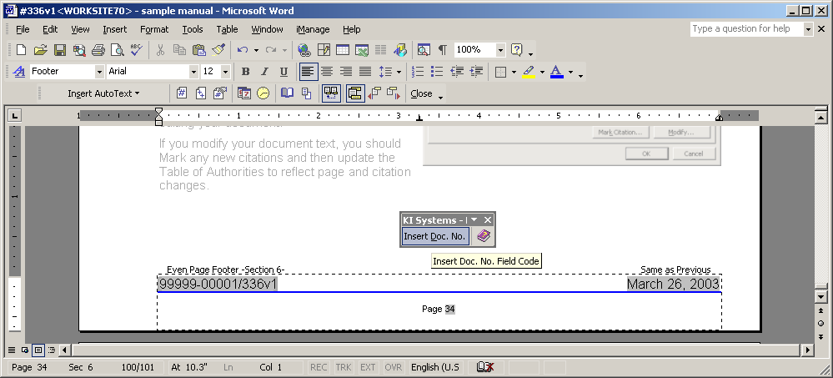

iManage DeskSite 6.0.1a HotFix 10a Footer Display Formats
This version includes the display of the following types of footers:
- Documents opened within Word from the Library include a footer display comprised of: Document Number “-“ Version Number “:” Client Number “-“ Matter Number
(e.g. 12345-1:99999-00001)
- Documents opened within Word while in Portable Mode include a footer display comprised of the Portable Extension “-“Document Number “-“ Version Number “:” Client Number “-“ Matter Number (e.g. #MH-12345-1:99999-00001)
- Documents opened outside the Library (i.e. using Local Open) include a footer display comprised of the Document’s Path and Name (e.g. c:\My Documents\Sample.doc)
- Email Attachments opened directly from your Mail program include a footer display comprised of the user’s Windows Temporary directory (e.g. C:\WINNT\Profiles\kristil\Local_Settings\Temporary_Internet_Files) and the Document’s Name.
 TIP: Attaching documents directly to email messages break the link between the document and Library. We recommend attaching a link rather than the actual document for in-house collaboration.
- iManage Desktop – Creating a Copy of a document using the iManage Desktop will not update the footer display in the newly created copy. The automatic updating of footer display information only occurs when the document is opened within Word. iManage Desktop commands such as Copy, Open or Print do direct the document to be opened within the Word application. As this occurs, the Footer Macro will automatically update the footer display as the document is opened in Word.
 TIP: Using the iManage Desktop – You should always select Copy and Open to allow the footer display to automatically update. A simple Copy does not allow the document to access Word and therefore the footer display cannot be updated.

To Un-Install the Footer Macro Software
- Click Start, Settings, Control Panel, Add/Remove Programs
- Locate KI Systems Footer Macros and click Remove
